SANDBOX DOCUMENTATION
(ABDM_Milestone 2)

Version 2.8
Created On 13.02.2026

Contents
1 Base URL and X-CM-ID 4
2.Terminology Definition: 4
3.Gateway 4
3.1 Overview 4
3.2List of APIs 4
3.2.1 Auth token API 4
3.2.2 OpenID Configuration API 6
3.2.3 Keycloak Certificate API 7
3.2.4 Update bridge URL API 10
3.2.5 Registration of Facility & Software Linkage 11
3.2.6 Find bridge by service id 13
3.2.7 Find services by bridge id 15
4 HIP Initiated Linking 18
4.1 Overview 18
4.2 Sequence Diagram 18
4.3 List of APIs 19
4.3.1 Link token generation 19
4.3.2 Callback API for Link token generation 25
4.3.3 Linking care context 34
4.3.4 Call back API for linking care context with patient ABHA address 42
4.3.5 Get all patient links 45
4.3.6 Notify care context update 48
4.3.7 Call back API for notify care context update 52
4.3.8 SMS Notification to patients 54
4.3.9 Callback API for SMS Notification to patients 57
5.User Initiated Linking 59
5.1 Overview 59
5.2 Sequence Diagram 60
5.3List of APIs 62
5.3.1 Patient Health record discovery 62
5.3.2 HIE-CM callback to HIP - Discovery 65
5.3.3 HMIS/LMIS response on health record discover 67
5.3.4 HIE-CM callback on Health record discover 74
5.3.5 Patient health record link init 76
5.3.6 HIE-CM callback on health record link init 81
5.3.7 HMIS/LMIS response on health record link 84
5.3.8 HIE-CM response on health record link 90
5.3.9 Patient health record confirm 93
5.3.10 HIE-CM callback for health record confirmation 96
5.3.11 HMIS/LMIS response on health record confirm 97
5.3.12 HIE-CM response on health record on-confirm 101
6.Data Flow 103
6.1 Overview 103
6.2 Sequence Diagram 103
6.3 List of APIs 104
6.3.1 Callback API to HIP when a consent request is APPROVED/REVOKED 104
6.3.2 HIP to respond back to consent HIP notify 109
6.3.3 Data Flow - Health information request – Callback to HIP 111
6.3.4 HIP acknowledgement to the health information request 113
6.3.5 HIP calling data push URL 115
6.3.6 Health Information notify API 118
7.Scan and Profile Share 121
7.1 Overview 121
7.2 Sequence Diagram 122
7.3 List of APIs 122
7.3.1 Profile share 122
7.3.2 Profile share – Callback 126
7.3.3 Profile on-share 129
7.3.4 Profile on share – Callback 132
8.API Listing 134
9.Error Codes Listing 138

1 Base URL and X-CM-ID
Environment | Base URL | X-CM-ID
Sandbox | https://dev.abdm.gov.in | Sbx
Production | https://apis.abdm.gov.in | Abdm

2.Terminology Definition:
Bridge ID: Is client ID which provided by NHA to HIP (Its alphanumerical eg:
SBX_00XXXX)
Service ID: Is Facility ID which is generated from NHPR application (Its alphanumeric eg: IN02100000XX)

3.Gateway

3.1 Overview
This is the key ABDM building block that manages ABHA addresses, maintains links to health data for each ABHA address and manages consents provided by the user for sharing of their health data. It also supports exchange of interoperable health data between HIPs and HIUs. The HIE-CM enables exchange of personal health data with consent as per the Health Data Management Policy issued by NHA.

3.2List of APIs

3.2.1 Auth token API
This API will be invoked to generate auth token.
URL: /api/hiecm/gateway/v3/sessions
Request: POST
Header Parameters:
Property Name | Example Value | Required | Description
REQUEST-ID | 18235d89-cb13-479d-ad71-  7a57d5f669a8 | Yes | Unique UUID for tracking the endtoend request transaction
TIMESTAMP | 2022-10-06T10:10:00.587Z | Yes | The actual time when the request was initiated, ISO Date time format represents the date and time
X-CM-ID | Sbx | Yes | Suffix of the consent manager to which the request was intended.
Body Parameters:
Property Name | Example Value |  | Required | Description
clientId | SBX_XXXXXX | Yes |  | Client id for authentication
clientSecret | “XXXXXXXXXXXXX” | Yes |  | Client secret for authentication
grantType | client_credentials | Yes |  | Grant type for authentication
Request Body:
Request Body
{
"clientId": "SBX_XXXXX",
"clientSecret": "XXXX-XXX-XXXX-XXXX-XXXXXXX",
"grantType": "client_credentials" }

Response:

Response
Code : 202 Accepted
{
"accessToken":
"eyJhbGciOiJSUzI1NiIsInR5cCIgOiAiSldUIiwia2lkIiA6ICJBbFJiNVdDbThUbTlFSl9JZk85ejA2ajlvQ3Y1MXBLS 0ZrbkdiX1RCdkswIn0.eyJleHAiOjE3MjMyMjU3MTEsImlhdCI6MTcyMzIyNDUxMSwianRpIjoiMzE3MjVkN2Qt
NmM1Mi00OWE0LTk0M2MtZmY2ZjhkNjNhYmRlIiwiaXNzIjoiaHR0cHM6Ly9kZXYubmRobS5nb3YuaW4vYX
V0aC9yZWFsbXMvY2VudHJhbC1yZWdpc3RyeSIsImF1ZCI6ImFjY291bnQiLCJzdWIiOiJjN2NhMjk3Yi0yZTVh
LTRkN2UtOGY5YS0xYWU2NDAxYWQ0Y2YiLCJ0eXAiOiJCZWFyZXIiLCJhenAiOiJTQlhfMDAwMTM1Iiwic2Vzc 2lvbl9zdGF0ZSI6IjhiYjQ4ZGM5LTJmMDUtNDA0OC05MGUxLWRjYjgxNWRmOGU5MyIsImFjciI6IjEiLCJhbGx vd2VkLW9yaWdpbnMiOlsiaHR0cDovL2xvY2FsaG9zdDo5MDA3Il0sInJlYWxtX2FjY2VzcyI6eyJyb2xlcyI6W yJIaWRJbnRlZ3JhdGVkUHJvZ3JhbSIsIkhJVV9QQVlFUiIsImhmciIsImhpdSIsIm9mZmxpbmVfYWNjZXNzIi wiaGVhbHRoSWQiLCJwaHIiLCJPSURDIiwiaGVhbHRoX2xvY2tlciIsImhpcCIsImhwX2lkIl19LCJyZXNvdXJjZV 9hY2Nlc3MiOnsiU0JYXzAwMDEzNSI6eyJyb2xlcyI6WyJ1bWFfcHJvdGVjdGlvbiJdfSwiYWNjb3VudCI6eyJy b2xlcyI6WyJtYW5hZ2UtYWNjb3VudCIsIm1hbmFnZS1hY2NvdW50LWxpbmtzIiwidmlldy1wcm9maWxlIl19f Swic2NvcGUiOiJvcGVuaWQgZW1haWwgcHJvZmlsZSIsImNsaWVudEhvc3QiOiIxMDAuNjUuMTYwLjIxNCI sImNsaWVudElkIjoiU0JYXzAwMDEzNSIsImVtYWlsX3ZlcmlmaWVkIjpmYWxzZSwicHJlZmVycmVkX3VzZXJ uYW1lIjoic2VydmljZS1hY2NvdW50LXNieF8wMDAxMzUiLCJjbGllbnRBZGRyZXNzIjoiMTAwLjY1LjE2MC4yMTQi fQ.L56AYZYfzFrO_gNedAbSwR9foEO661z2cMGEeOKsz2ZXsIpTb9oLd9fmRiixIS7ToGoW2VzzXC14qrXnwZIqknBZchTRJrmyGk6iRJ NQYR4k12hrn4tbdW- h5e9m4NWFAvPtGbBUyKA8gotrne9fn7T0MOC7N_J8TS3JLr2gothJSgc9P3VDKm8c6zpAObQPmwEpH qJH6j2Q07nGsoaBygxovoIeFn6G6zwIa-_mKw_a86L_CYxr8Gxw5-
5PXkh2XwYp_xLIiJ3t7vLM97UFThwSn_TmRF6W1LH145m_6NxY4hQclHi1elK3OP4LvR1SLDwtAQZSCm4Jpihd0uMw",
"expiresIn": 1200, "refreshExpiresIn": 1800,
"refreshToken":
"eyJhbGciOiJIUzI1NiIsInR5cCIgOiAiSldUIiwia2lkIiA6ICIyMWU5NzA4OS00ZTcxLTQyNGEtOTAzYS1jOTAyMW
M1NmFlNWYifQ.eyJleHAiOjE3MjMyMjYzMTEsImlhdCI6MTcyMzIyNDUxMSwianRpIjoiZGY5ODdmYzQtYzdk Ni00OGNmLTliM2EtNzRmNWVkMTljMmNmIiwiaXNzIjoiaHR0cHM6Ly9kZXYubmRobS5nb3YuaW4vYXV0a C9yZWFsbXMvY2VudHJhbC1yZWdpc3RyeSIsImF1ZCI6Imh0dHBzOi8vZGV2Lm5kaG0uZ292LmluL2F1dGg vcmVhbG1zL2NlbnRyYWwtcmVnaXN0cnkiLCJzdWIiOiJjN2NhMjk3Yi0yZTVhLTRkN2UtOGY5YS0xYWU2ND AxYWQ0Y2YiLCJ0eXAiOiJSZWZyZXNoIiwiYXpwIjoiU0JYXzAwMDEzNSIsInNlc3Npb25fc3RhdGUiOiI4YmI0O GRjOS0yZjA1LTQwNDgtOTBlMS1kY2I4MTVkZjhlOTMiLCJzY29wZSI6Im9wZW5pZCBlbWFpbCBwcm9maWx lIn0._cOnTXMf2bObS1nySL-AjvM5PQxgCHJRm2oO66nrx1M",
"tokenType": "bearer"
}

3.2.2 OpenID Configuration API
Openid-configuration API, defined within OpenID Connect which provides configuration information about the Identity Provider (IDP).
URL: /api/hiecm/gateway/v3/.well-known/openid-configuration Request: GET Header Parameters:

Property Name | Example Value | Required | Description
REQUEST-ID | 18235d89-cb13-479d-ad71-  7a57d5f669a8 | Yes | Unique UUID for tracking the endtoend request transaction
TIMESTAMP | 2022-10-06T10:10:00.587Z | Yes | The actual time when the request was initiated, ISO Date time format represents the date and time
X-CM-ID | Sbx | Yes | Suffix of the consent manager to which the request was intended.

Response:

Response
Code : 202 OK
{
"jwks_uri": "https://dev.abdm.gov.in/api/hiecm/gateway/v3/certs"
}

3.2.3 Keycloak Certificate API
In response to open ID configuration API, Keycloak, the open-source identity provider, provides an OAuth certificate that can be used with open source authentication requests for certificates.
URL: /api/hiecm/gateway/v3/certs
Request: GET
Header Parameters:
Property Name | Example Value | Required | Description
REQUEST-ID | 18235d89-cb13-479d-ad71-  7a57d5f669a8 | Yes | Unique UUID for tracking the endtoend request transaction
TIMESTAMP | 2022-10-06T10:10:00.587Z | Yes | The actual time when the request was initiated, ISO Date time format represents the date and time
X-CM-ID | sbx | Yes | Suffix of the consent manager to which the request was intended.

Response:

Response
Code : 202 OK
{
"keys": [
{
"e": "AQAB",
"kid": "AlRb5WCm8Tm9EJ_IfO9z06j9oCv51pKKFknGb_TBvK0",
"kty": "RSA",
"n": "mgmW7W5ZGF_G5cJevwYi8HiPcI-6qS_psnZxa4v3bkwAkyOoOd8-6ketrOI-
ZA2PbRbGnxFfZHiI94rdFXJ4Q9ampscsz9NocTIPMPmWydJ8A50pZaYWyikYDSJiDltq7i3WspPKSOuQHrC
5h9dMcCVveX5oeg0tO68Z79gwDlpcxiqDbFaphsqDvx-
5XkfwiqvOBaybK6_BCBPuTqWMUEuUklLYXu2X7ESHdVNFMFAjxCcCXUtP7LFdvT3nnFekRmG82QbSQSVe 4N5tPH8q0MCxSWWn2c15bDnzOF-dvfRCVPRabCzw0M-utHR9diTrWtq6Koi5buxgwM1rbk0p8Q",
"use": "sig",
"x5c": [

"MIICrzCCAZcCBgFy/3WZBjANBgkqhkiG9w0BAQsFADAbMRkwFwYDVQQDDBBjZW50cmFsLXJlZ2lzdHJ5
MB4XDTIwMDYyOTA5NDEzNloXDTMwMDYyOTA5NDMxNlowGzEZMBcGA1UEAwwQY2VudHJhbC1yZWdpc
3RyeTCCASIwDQYJKoZIhvcNAQEBBQADggEPADCCAQoCggEBAJoJlu1uWRhfxuXCXr8GIvB4j3CPuqkv6b J2cWuL925MAJMjqDnfPupHraziPmQNj20Wxp8RX2R4iPeK3RVyeEPWpqbHLM/TaHEyDzD5lsnSfAOdKWW mFsopGA0iYg5bau4t1rKTykjrkB6wuYfXTHAlb3l+aHoNLTuvGe/YMA5aXMYqg2xWqYbKg78fuV5H8Iqrzg WsmyuvwQgT7k6ljFBLlJJS2F7tl+xEh3VTRTBQI8QnAl1LT+yxXb0955xXpEZhvNkG0kElXuDebTx/KtDAsUllp9

nNeWw58zhfnb30QlT0Wmws8NDPrrR0fXYk61rauiqIuW7sYMDNa25NKfECAwEAATANBgkqhkiG9w0BAQs FAAOCAQEACkC3TijrXIgi4vn+l1uL1nfdK6vOIL5UZ6yCjSOq7zYW6b3Qe8j7NrPb9RJC+pbIERyNbB+t9hsa5 g1L7lkjCNlUuxfJprsJ9LJKlM5g7dYEA6XPCJ7C6AVlarj72vlWXQvwjnQMO2/CM9/Jp5Hnv2Qwjn7NME2OW M0iblc/TD+DEZK5L5mlWMyuBSQo2o/AcOmfG4MoE5Gm/CaOJ47rSrf+lq83e5+dyKh7uLVAa+5WK8Im
5nEs6BLSGyo2KlaV0mW9yCkoRLLbipjH8+rJwkUU6iu7QVjz0peGZzYldya5n35gMWH7Bu4HqFneKNRww D6w8rGNC+uWtgWejDZ3yQ=="
],
"x5t": "EaMhYGUIvMkp8tvSM3QoaqaF8xM",
"x5t2": "vGer6Pt8AhZn8RlbHhAFksOCcGf3u1UWU7Qq-Doy7ro",
"alg": "RS256"
},
{
"e": "AQAB",
"kid": "oc-l6O1yJ7wJKYEeyeUafsz3Aecq7YnCIqbzbIfkJk8",
"kty": "RSA", "n":
"jDOehgMzurNQT0WJCTWN6a34639uIKOLO1LnXZes_kTakWh6iRxmkExLLCD7MJjz9aijTHwIuKAtOCSbFO pwbqSfF6dMBS2c8cv0AU3pE8
BuUriwr9BUYSUW8SM68QH_HCaz2mmN_Z8ynTQ4kWw_Idj- enVpkHYtq00DriG98l6RXF1Ao9Kd16ctoNbthuQYH0RSRIXnt0Qtm4GSAY7abPCNa64mir0auldU72DJHXwDo6g5OGz6EMm86ZAV_pvh_5Y IMxv0yMMKFZjkFGA0QKYMkMTC5ruLaE7cec-njA7dJQnQ",
"use": "sig",
"x5c": [

"MIICrzCCAZcCBgGHxvQVmDANBgkqhkiG9w0BAQsFADAbMRkwFwYDVQQDDBBjZW50cmFsLXJlZ2lzdHJ 5MB4XDTIzMDQyODA4MTk1N1oXDTMzMDQyODA4MjEzN1owGzEZMBcGA1UEAwwQY2VudHJhbC1yZWdpc
3RyeTCCASIwDQYJKoZIhvcNAQEBBQADggEPADCCAQoCggEBAIwznoYDM7qzUE9FiQk1jemt+Ot/biCjiztS
512XrP5E2pFoeokcZpBMSywg+zCY8/Woo0x8CLigLTgkmxTqcG6knxenTAUtnPHL9AFN6RPJEjKRiSg2fXYg PgblK4sK/QVGElFvPkjOvEB/xwms9ppjf2fMp00OJFsPyHY/np1aZB2LatNA64hvfJekVxdQKPSndenLaDW7Y bkGB9EUkSF57dELZuBkgGO2mzwjWuuJoq9PmrpXVPu9gyR18A6OoOThs+hDJvOmQFf6b4f+WMxaX5FA PEytixVQJgt1KfiDMb9MjDChWY5BRgNECmDJDEwua7i2hO3HnPp4wO3SUJ0CAwEAATANBgkqhkiG9w0B
AQsFAAOCAQEABYAcXOSr+WgOxKVmygID9WjB4rDuAVDyU3GmjBvckdWhYJuBX8Vs04hNVNgf904gqy
+D5wZIQU985stK3PdogFGN2jVw2kO9G3hG4/7uwYKqciKApT/pSPMeHRltHGp/Mwr6e5poVwgQyrn+Be
H373U1Q6eB1QUYnElP+16y7bbvQhfDAS2X9sqdfurB9YIL5xZMPddZaf7pPX8oWOVlB0XH1JEZfsX125qq0Xn
K8z/Rd8KI8zTfJw6D2Kzrk1WvQSlM5KnTQmcSk3kwDlW5Dg657dT49Y68mI4azq34q17JgBhTx3IbTuf94QT w7QC5wmFtO+hc6zPVODX8JW

],
"x5t": "-HZ-fkkNBhTsPHWrhATwlZflhdU",
"x5t2": "tjVDNCTx7Fn0TfM-6uHvbwjWlIxIaFtGxiZZ6uJFxr4",
"alg": "RS512"
}
]
}

3.2.4 Update bridge URL API
This API will be called to update the bridge base URL.
URL: /api/hiecm/gateway/v3/bridge/url
Request: PATCH
Header Parameters:
Property Name | Example Value |  | Required | Description
Authorization | eyJhbGciOiJSUzUxMiJ9. eyJzdWIiOiJ2YXNhbnRoY Wt1bWFyLmtlc2F2YW5Ac  2J4IiwiY2xpZW50SWQiOi  JzYngiLCJzeXN0ZW0iOiJ  BQkhBLUEiLCJyZXF1ZXN0Z  XJJZCI6IlBIUi1XRUIiLCJwa  HJNb2JpbGUiOm51bGws | Yes |  | JWT Access token which was issued by ABDM session API after successful validation of client id and secret.
REQUEST-ID | 18235d89-cb13-479dad71-  7a57d5f669a8 | Yes |  | Unique UUID for tracking the end-to-end request transaction
TIMESTAMP | 2022-10-  06T10:10:00.587Z | Yes |  | The actual time when the request was initiated, ISO Date time format represents the date and time
X-CM-ID | sbx | Yes |  | Suffix of the consent manager to which the request was intended.

Body Parameters:
Property Name | Example Value |  | Required | Description
url | https://webhook.site/b7  99c0b8-4e75-4545- 8eb2d8c2d5f0c9f6 | Yes |  | Bridge base URL
Request Body:
Request Body
{
"url": "https://webhook.site/b799c0b8-4e75-4545-8eb2-d8c2d5f0c9f6"
}

Response:

Response
Code : 202 Accepted

3.2.5 Registration of Facility & Software Linkage

Overview: The software being used by the provider must integrate with the digital building blocks of ABDM and comply with the guidelines outlined NHA. NHA maintains the national directory of all healthcare facilities. Any participating facility needs to sign up in the health facility registry at (nhpr.abdm.gov.in) This ensures that they are a valid facility which is authorized to issue health records in the ecosystem. HFR consists of information for each healthcare facility in the country – hospitals, clinics, diagnostic centres, pharmacies etc., across all systems of medicine and covering both public and private health facilities. HFR offers APIs that can be used by various stakeholders in the ecosystem. Healthcare information service provider application or healthcare repository provider application must be upgraded to become ABDM compliant.

Registration of facility:

Through website: https://hspsbx.abdm.gov.in/home (sandbox) , https://nhpr.abdm.gov.in/home (production) Step-by-step user manual document access:
Goto https://hspsbx.abdm.gov.in/home (sandbox), https://nhpr.abdm.gov.in/home
(production) >>Resource center >> User Manual
>> Select “For Health Fecility” >>Download “User Manual” >>Refer Content
“A” (Health Professional ID (HPID) creation), “B” (Facility Registration) Registration of bridge services (HIP/HIU) on facility:

Option 1: Linking through website: https://hspsbx.abdm.gov.in/home (sandbox), https://nhpr.abdm.gov.in/home (production) Step-by-step user manual document access:
Goto: https://hspsbx.abdm.gov.in/home (sandbox) , https://nhpr.abdm.gov.in/home (production) >>Resource center >> User Manual >> Select “For Health Facility” >>Download “User Manual” >>Refer Content “C” (Software Linkage).

Option 2: Through API This API (https://apihspsbx.abdm.gov.in/v4/int/v1/bridges/MutipleHRPAddUpdateServices ) will be used to link multiple bridges against a facility. It will accept the facility id , facility name and list of HRP i.e. bridges.
Please note:
- You must pass in all the required parameters to create the API.
- The data needs to be passed in the required format as mentioned for each field.
API can refer swagger link :
https://apihspsbx.abdm.gov.in/v4/int/swagger-ui-ext/index.html#/Multiple%20HRP%20API/facilityAddAndUpdate >>>Go to Multi HRP API >>>and Select
“/v1/bridges/MutipleHRPAddUpdateServices v1MutipleHRPAddUpdateServices”

Parameters:
Params | Required | Description | Data  type | Format if any
facilityId | Yes | Will be validated if present in  HFR or not | String | Starting with IN and of 12 characters
facilityName | Yes | Name of the facility to be linked | String | Alphanumeric
bridgeId | Yes | Valid Bridge Id to be linked. | String | Alphanumeric and validity to be checked by  HIECM
hipName | Yes | • To provide uniqueness against each bridges that is linked . HIP name is the | String | • HIP name can be the Hospital  name added
 |  | name of the hospital which will reflect |  | with suffix of bridge name.  example
 |  | on ABHA/PHR app when the patent will search respective hospital. |  | Hospital  name=XYZ  and bridge name =BRIDGE TEST, so the HIP name =  XYZ BRIDGE. • HIP name can not be more  than 15 characters., No special  character is allowed  (%$*#@(~&!), and it should be unique for every bridge  for a facility
type | Yes | HIP / HIU etc | String | Validated by  HIECM
Active | Yes | True/false | boolean | Accept  Boolean value

3.2.6 Find bridge by service id
This API will fetch the bridge details for the given service id.
URL: /api/hiecm/gateway/v3/bridge-service/serviceId/{serviceId}
Request: GET
Header Parameters:
Property Name | Example Value |  | Required | Description
Authorization | eyJhbGciOiJSUzUxMiJ9. eyJzdWIiOiJ2YXNhbnRoY Wt1bWFyLmtlc2F2YW5Ac  2J4IiwiY2xpZW50SWQiOi JzYngiLCJzeXN0ZW0iOiJ  BQkhBLUEiLCJyZXF1ZXN0Z  XJJZCI6IlBIUi1XRUIiLCJwa HJNb2JpbGUiOm51bGws  ImV4cCI6MTY2NzI5ODEx NSwiaWF0IjoxNjY3MjkwO TE1LCJwaHJBZGRyZXNzIjo idmFzYW50aGFrdW1hci5 rZXNhdmFuQHNieCIsInR 4bklkIjoiYjEwMGM4ZDMt NTE1ZC00YWFiLTg1OWQtY zNlMTUwOTE3ZGY1In0 | Yes |  | JWT Access token which was issued by ABDM session API after successful validation of client id and secret.
REQUEST-ID | 18235d89-cb13-479dad71-  7a57d5f669a8 | Yes |  | Unique UUID for tracking the end-to-end request transaction
TIMESTAMP | 2022-10-  06T10:10:00.587Z | Yes |  | The actual time when the request was initiated, ISO Date time format represents the date and time
X-CM-ID | sbx | Yes |  | Suffix of the consent manager to which the request was intended.

Response:

Response
Code : 200 Ok
{
"id": 1561,
"bridgeId": "SBX_XXXX",
"serviceId": "TestClinicHIP",
"name": "TestClinicHIP",
"isHip": true,
"isHiu": true,
"isPhr": false,
"endpoints": {},
"active": true,
"registerTime": "2021-03-01 11:17:35.1735",
"dateCreated": "2021-03-01 11:17:35.1735",
"dateModified": "2024-04-22 11:04:46.446"
}

3.2.7 Find services by bridge id
This API will fetch all the service ID details linked with the respective bridge id.
URL: /api/hiecm/gateway/v3/bridge-services'
Request: GET
Header Parameters:
Property Name | Example Value |  | Required | Description
Authorization | eyJhbGciOiJSUzUxMiJ9. eyJzdWIiOiJ2YXNhbnRoY Wt1bWFyLmtlc2F2YW5Ac  2J4IiwiY2xpZW50SWQiOi  JzYngiLCJzeXN0ZW0iOiJ  BQkhBLUEiLCJyZXF1ZXN0Z  XJJZCI6IlBIUi1XRUIiLCJwa  HJNb2JpbGUiOm | Yes |  | JWT Access token which was issued by ABDM session API after successful validation of client id and secret.
REQUEST-ID | 18235d89-cb13-479dad71-  7a57d5f669a8 | Yes |  | Unique UUID for tracking the end-to-end request transaction
TIMESTAMP | 2022-10-  06T10:10:00.587Z | Yes |  | The actual time when the request was initiated, ISO Date time format represents the date and time
X-CM-ID | sbx | Yes |  | Suffix of the consent manager to which the request was intended.

Response:

Response
Code : 200 Ok
{
"bridge": {
"id": "SBX_XXXX",
"name": "Testing",
"url": "https://abdcb.doctor9.com",
"active": true,
"blocklisted": false
},
"services": [
{
"id": "@#$%^&*(",
"name": "hello",
"types": [
"HIP",
"HIU"

],
"endpoints": {
"hipEndpoints": [
{
"use": "registration",
"connectionType": "HTTPS",
"address":
"https://events.hookdeck.com/e/src_3gsnEgI941mh/registration"

},
{
"use": "data-upload",
"connectionType": "HTTPS",
"address":
"https://events.hookdeck.com/e/src_3gsnEgI941mh/dataupload"
}
],
"hiuEndpoints": [
{
"use": "registration",
"connectionType": "HTTPS",
"address":
"https://events.hookdeck.com/e/src_3gsnEgI941mh/registration"
},
{
"use": "data-upload",
"connectionType": "HTTPS",
"address":
"https://events.hookdeck.com/e/src_3gsnEgI941mh/dataupload"
}
],
"healthLockerEndpoints": [
{
"use": "registration",
"connectionType": "HTTPS",
"address":
"https://events.hookdeck.com/e/src_3gsnEgI941mh/registration"
},
{
"use": "data-upload",
"connectionType": "HTTPS",
"address":
"https://events.hookdeck.com/e/src_3gsnEgI941mh/dataupload"
}
]
},
"active": true
}
] }

4 HIP Initiated Linking

4.1 Overview

HIP-initiated linking is the process through which a HIP links the patient’s care context (health record) with the patient's ABHA Address, after patient registration and creation of health records (in their HMIS/LMIS system).
Care context (Health record) linking happens in two steps.
- Link token generation
- Linking care context with ABHA address after obtaining a valid link token

Link token generation
To achieve linking, the HIPs need to have a valid link token using link token service
The link token will be used for linking the ‘n’ number of care contexts, and concurrent linkages.

4.2 Sequence Diagram

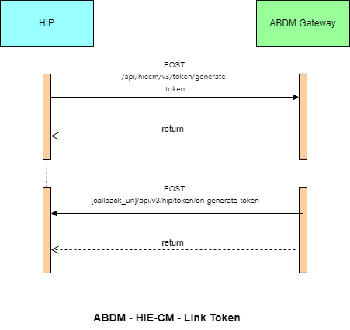
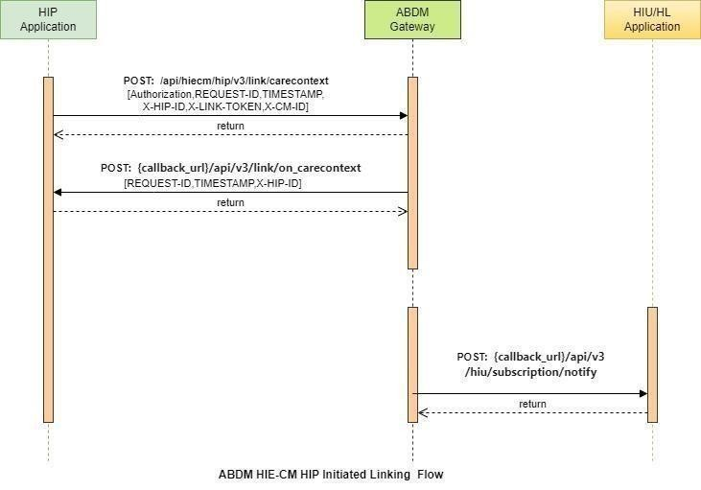

4.3 List of APIs

4.3.1 Link token generation

This API invoked by HIP or HRP to generate a link token.
URL: /api/hiecm/v3/token/generate-token Method:
POST Request Headers:

Property  Name | Example Value | Required | Description
REQUEST-ID | 18235d89-cb13-479d-ad71-  7a57d5f669a8 | Yes | Unique UUID for tracking the end-toend request transaction
TIMESTAMP | 2022-10-06T10:10:00.587Z | Yes | The actual time when the request was initiated, ISO Date time format represents the date and time
Authorization | eyJhbGciOiJSUzUxMiJ9.  eyJzdWIiOiJ2YXNhbnRoYWt1bWFyLmtlc2F2  YW5Ac2J4IiwiY2xpZW50SWQiOiJz  YngiLCJzeXN0ZW0iOiJBQkhBLUEiLCJy  ZXF1ZXN0ZXJJZCI6IlBIUi1XRUIiL  CJwaHJNb2JpbGUiOm51bGwsImV4c  CI6MTY2NzI5ODExNSwia  WF0IjoxNjY3MjkwOTE1LCJwaHJBZ  GRyZXNzIjoidmFzYW50aGFrdW1hci5rZX  NhdmFuQHNieCIsInR4bklkIjoi  YjEwMGM4ZDMtNTE1ZC00YWFiLTg1O  WQtYzNlMTUwOTE3ZGY1In0 | Yes | JWT Access token which was issued by ABDM session API after successful validation of client id and secret
X-HIP-ID | IN2810014366 | Yes | Identifier of the health information provider to which the request was intended
X-CM-ID | sbx | Yes | Suffix of the consent manager to which the request was intended

Body Parameters:

Property Name | Example Value | Required | Description
abhaAddress | “ABHA address” | Yes (if ABHA number is not provided) | Patient ABHA address against which the health records need to be linked.
abhaNumber | ABHA number | Yes (if ABHA address is not provided) | 14-digit unique ABHA number of the patient.
Name | “Full name” | Yes | Patient's full name in the following format First Name | Middle Name | Last Name
Gender | “M”/”F”/”O” | Yes | Patient gender
yearOfBirth | XXXX | Yes | Patient's year of birth

Request Body:

Request Body
{
"abhaNumber": 98765432101XXXX,
 | "abhaAddress": "user@sbx",  } | "name": "Arjun",  "gender": "M",  "yearOfBirth": XXXX

Response Body:

Response:
Code : 202 Accepted

Error scenarios:
Scenario | Request Headers/Body | Message
When Request ID is Blank, null or empty in header | [  {  "key": "REQUEST-ID",  "value": "",  "type": "text"  } ] | Access Denied  Code : 403 Forbidden

When invalid Request- ID is pass in header | [  {  "key": "REQUEST-ID",  "value": "{{$guid}}zxzzxs",  "type": "text"  }  ]  [  {  "key": "TIMESTAMP",  "value": "",  "type": "text"  } ] | {  "code": "ABDM-1030: ",  "message": "Invalid request ID"  }  Code: 400Bad Request  Access Denied  Code : 403 Forbidden  {  "code": "ABDM-1016: ",  "message": "Invalid Timestamp"  }  Code - 400Bad Request
When Timestamp is Blank, null or empty in header.
When invalid  Timestamp is pass in header | [  {  "key": "TIMESTAMP", "value": "{{$isoTimestamp}}jh gftytgtyu",  "type": "text"  } ]
When X-HIP-ID is Blank, null or empty in header. | [  {  "key": "X-HIP-ID",  "value": "",  "type": "text"  }  ]  [  {  "key": "X-CM-ID",  "value": "sbxdvdfvdf",  "type": "text"  } ] | Access Denied  Code : 403 Forbidden  Access Denied  Code : 403 Forbidden  {  "code": "ABDM-1064",  "message": "Request body was missi ng"  }  Code : 400Bad Request  {  "code": "ABDM-1092",  "message": "Duplicate Link token req uest"  }  Code : 400Bad Request
When X-CM-ID is
Invalid, Blank, null or empty in header.
Request body missing
Duplicate Link token request | {  "abhaNumber": 9117838618XXXX,  "abhaAddress": "9117838610XXXX  @sbx",  "name": "Mayur Chaskar",  "gender": "M",  "yearOfBirth": XXXX

 | }  {  "abhaNumber": null,  "abhaAddress": null,  "name": "Mayur Bapu",  "gender": "M",  "yearOfBirth": XXXX } | {  "code": "ABDM-1125",  "message": "ABHA number and ABH A address cannot be null"  }  Code - 400Bad Request
ABHA number and ABHA
address cannot be null
When passing an abha number of more or less than  14 digits | {  "abhaNumber": 911783861017XXX,  "abhaAddress": "91178386101731X  XXX@sbx",  "name": "Mayur M ",  "gender": "M",  "yearOfBirth": XXXX }  {  "abhaNumber": 91178386109XXXX  ,  "abhaAddress": "9117838610XXX@ gmail.com",  "name": "Mayur M",  "gender": "M",  "yearOfBirth": 1994 }  {  "abhaNumber": 9117838610XXXX,  "abhaAddress": "911783861XXXX@ sbx",  "name": "Mferr",  "gender": "M", "yearOfBirth": 1994  } | [  {  "code": "ABDM-9999: ",  "message": "Invalid ABHA Number, it must be only 14 digit"  } ]  Code - 400Bad Request  [  {  "code": "ABDM-9999: ",  "message": "Invalid ABHA Address, it must start with Alphanumeric . and _ in the middle and must be ending with @abdm or @sbx"  } ]  Code - 400Bad Request  Callback: {  "error": {  "code": "ABDM-1207: ",  "message": "Demographic details was invalid or doesn't exists"  },  "response": {  "requestId": "58f080de-b5444bcf-8f4b-  3d45222b2885"  } }  Code- 202Accepted
When passing invalid abha address/Invalid domain.
When passing invalid Name

When passing invalid  Gender except M, F, O, D | {  "abhaNumber": 9117838610XXXX,  "abhaAddress": "9117838610XXXX  @sbx",  "name": "Mayur B ",  "gender": "W",  "yearOfBirth": XXXX }  {  "abhaNumber": 9117838610XXX,  "abhaAddress": "9117838610XXX@ sbx",  "name": "Mayur B",  "gender": "M", "yearOfBirth": XX  } | [  {  "code": "ABDM-9999: ",  "message": "Invalid Gender, It mus t be M,  F, O, D"  } ]  Code- 400Bad Request  [  {  "code": "ABDM-9999: ",  "message": "Invalid Year of birth, must be  4 digit range between 1900 a nd 2200"  } ]  Code- 400Bad Request  Callback: {  "error": {  "code": "ABDM-1207: ",  "message": "Demographic details was invalid or doesn't exists"  },  "response": {  "requestId": "89d2dcb4-06a545fa-8910-  417d6e83bdd5"  } }  Code- 202Accepted  Callback: {  "error": {  "code": "ABDM-1207: ",  "message": "Demographic details was invalid or doesn't exists"  },  "response": {  "requestId": "58f080de-b5444bcf-8f4b-  3d45222b2885"  } }  Code- 202Accepted  Callback: {  "error": {  "code": "ABDM-1207: ",
Year Of Birth should be in between 1900 to 2200.
When passing F, O, D gender for male. | {  "abhaNumber": 9117838610XXXX,  "abhaAddress": "9117838610XXXX  @sbx",  "name": "Mayur B ",  "gender": "F",  "yearOfBirth": XXXX }
When Year of birth not matching with user’s YearOfBirth.  (Allowing +2 & -2 from original year) | {  "abhaNumber": 9117838610XXXX,  "abhaAddress": "9117838610XXXX  @sbx",  "name": "Mayur B",  "gender": "M",  "yearOfBirth": XXXX }
When abha numbe r is passing of another’s user. | {  "abhaNumber": 9117838610XXXX,  "abhaAddress": "9117838610XXXX  @sbx",
 | "name": "Mayur B ",  "gender": "F",  "yearOfBirth": XXXX } | "message": "Demographic details was invalid or doesn't exists"  },  "response": {  "requestId": "58f080de-b5444bcf-8f4b-  3d45222b2885"  } }  Code- 202Accepted  Callback: {  "error": {  "code": "ABDM-1207: ",  "message": "Demographic details was invalid or doesn't exists"  },
When abha Address is passing of another’s user. | {  "abhaNumber": 9117838610XXXX,  "abhaAddress": "9117838610XXXX  @sbx",  "name": "Mayur B",  "gender": "F", "yearOfBirth": XXXX  } | "response": {  "requestId": "89d2dcb4-06a545fa-8910-  417d6e83bdd5"  } }  Code- 202Accepted  Callback: {  "abhaAddress": "91178386101731@sbx  ",  "error": {  "code": "ABDM-1027: ",  "message": "You are blocked. Plea se try again after 24 hours."  },
When the user tries to generate a link token more than 3 times | {  "abhaNumber": 9117838610XXXX,  "abhaAddress": "9117838610XXXX  @sbx",  "name": "Mayur B",  "gender": "M", "yearOfBirth": XXXX  } | "response": {  "requestId": "ddcd6213-49e24d46-ad44-  07897c63c36b"  } }

4.3.2 Callback API for Link token generation

This is a callback API triggered by HIE-CM to HIP/HRP to get the link token.
URL: {callback_url}/api/v3/hip/token/on-generate-token
Method: POST

Request Headers:

Property  Name | Example Value | Required | Description
REQUEST-ID | 18235d89-cb13-479d-ad71-  7a57d5f669a8 | Yes | Unique UUID for tracking the end-toend request transaction.
TIMESTAMP | 2022-10-06T10:10:00.587Z | Yes | The actual time when the request was initiated, ISO Date time format represents the date and time
X-HIP-ID | IN2810014366 | Yes | Identifier of the health information provider to which the request was intended.
Authorization | eyJhbGciOiJSUzUxMiJ9.  eyJzdWIiOiJ2YXNhbnRoYWt1bWFyLmtlc2F2  YW5Ac2J4IiwiY2xpZW50SWQiOiJz  YngiLCJzeXN0ZW0iOiJBQkhBLUEiLCJy  ZXF1ZXN0ZXJJZCI6IlBIUi1XRUIiL  CJwaHJNb2JpbGUiOm51bGwsImV4c  CI6MTY2NzI5ODExNSwia  WF0IjoxNjY3MjkwOTE1LCJwaHJBZ  GRyZXNzIjoidmFzYW50aGFrdW1hci5rZX  NhdmFuQHNieCIsInR4bklkIjoi  YjEwMGM4ZDMtNTE1ZC00YWFiLTg1O  WQtYzNlMTUwOTE3ZGY1In0 | Yes | JWT Access token which was issued by ABDM session API after successful validation of client id and secret

Body parameters:

Property  Name |  | Example Value | Required | Description
abhaAddress | ABHA address |  | Yes (if ABHA number is not provided) | Patient ABHA address against which the health records need to be linked
linkToken | eyJhbGciOiJSUzUxMiJ9.eyJoaXBJZCI6Ik1BRE hVUkFfSElQIiwic3ViIjoiMTAwMDAyNjIxMzE2N DBAYWJkbSIsImFiaGFOdW1iZXIiOjEwMDAwM jYyMTMxNjQwLCJleHAiOjE2OTc1OTY2MDAsI mlhdCI6MTY4MTgyODYwMCwidHJhbnNhY3 Rpb25JZCI6IjM1YjkzYzQwLWM1OGQtNDk2ZC  04MDgxLWY1OTM0MWVkNGNkNSIsImFiaGFB ZGRyZXNzIjoiMTAwMDAyNjIxMzE2NDBAYWJk bSJ9.q-  p8eHxdacvSg2QPzm7vY7_kLHYCQXwkbkAc EvSwcp5HFAdtUyNoZ50LyquQih2Lbxv0Dxm  Da3YxyMnQY37GJsBpcs-  4OQmUk5tvoad1HYGjBVMlq0tVae7gpFHno nSSyhkVPGLTO5G4tvghvcK8xcMqoQol_lmR  26VIGCue07nx6K4xPueUOQeeqKMXPJs115wPunafT3LT24  k9KEHzbmDcWDJjUouBZ4TKAXcGrfwOuhG  M0eWr-  SMZ99PAlTHxHCZnJybUWL9E2MH6bpq87wD hFPrq0WLzhLJhynnfaWxrd7JkFdUtDygkpaiR h3V12xVqx8eWaSwxdwvCLut4A |  | Yes | Patient full name: First Name |  Middle Name |  Last Name
requestId | d6d6d056-666a-4af8-b6804c61bcb29dd4 |  | Yes | Unique UUID to  track the  endtoend flow

Request Body:

Request Body
{
"abhaAddress": "10000262131640@sbx",
"linkToken": "eyJhbGciOiJSUzUxMiJ9.eyJoaXBJZCI6Ik1BREhVUkFfSElQIiwic3ViIjoiMTAwMDAyNjIxMzE2 NDBAYWJkbSIsImFiaGFOdW1iZXIiOjEwMDAwMjYyMTMxNjQwLCJleHAiOjE2OTc1OTY2MDAsImlhdCI6MT Y4MTgyODYwMCwidHJhbnNhY3Rpb25JZCI6IjM1YjkzYzQwLWM1OGQtNDk2ZC04MDgxLWY1OTM0MWV kNGNkNSIsImFiaGFBZGRyZXNzIjoiMTAwMDAyNjIxMzE2NDBAYWJkbSJ9.q- p8eHxdacvSg2QPzm7vY7_kLHYCQXwkbkAcEvSwcp5HFAdtUyNoZ50LyquQih2Lbxv0DxmDa3YxyMnQ Y37GJsBpcs-
4OQmUk5tvoad1HYGjBVMlq0tVae7gpFHnonSSyhkVPGLTO5G4tvghvcK8xcMqoQol_lmR26VIGCue07
-
nx6K4xPueUOQeeqKMXPJs115wPunafT3LT24k9KEHzbmDcWDJjUouBZ4TKAXcGrfwOuhGM0eWrSMZ99PAlTHxHCZnJybUWL
9E2MH6bpq87wDhFPrq0WLzhLJhynnfaWxrd7JkFdUtDygkpaiRh3V12xVqx8 eWaSwxdwvCLut4A",
"response": {
"requestId": "d6d6d056-666a-4af8-b680-4c61bcb29dd4"
} }

Response Body

Response
Code : 202 Accepted

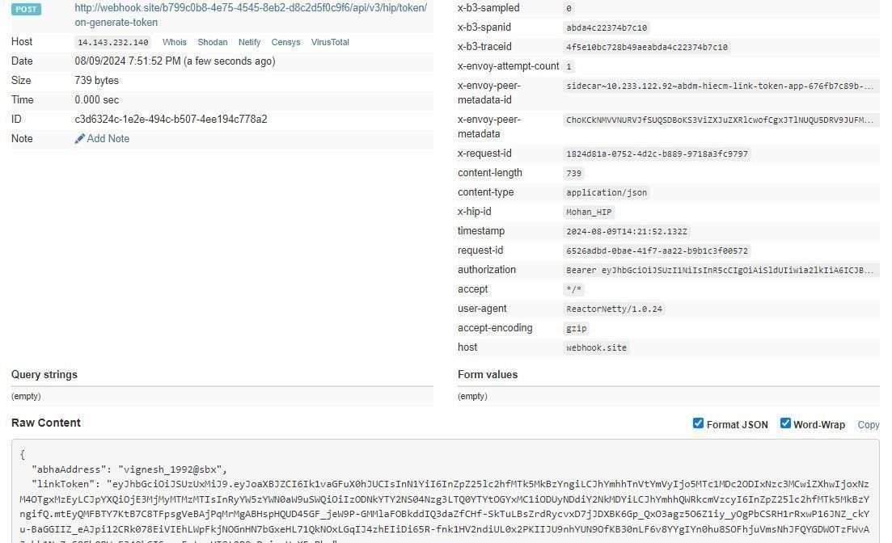

Error Scenarios:
Scenario | Headers/Body | Message
When Request ID is Blank, null or empty in header | [  {  "key": "REQUEST-ID",  "value": "",  "type": "text"  } ] | Access Denied  Code : 403 Forbidden
When invalid Request- ID is pass in header | [  {  "key": "REQUEST-ID",  "value": "{{$guid}}zxzzxs",  "type": "text"  } ] | {  "code": "ABDM-1030: ",  "message": "Invalid request ID"  }  Code: 400Bad Request
When Timestamp is Blank, null or empty in header. | [  {  "key": "TIMESTAMP",  "value": "",  "type": "text"  } ] | Access Denied  Code : 403 Forbidden
When invalid Timestamp is pass in header | [  {  "key": "TIMESTAMP", | {  "code": "ABDM-1016: ",  "message": "Invalid Timestamp"  }

 | "value": "{{$isoTimestamp}}jhgftyt gtyu",  "type": "text"  } ] | Code - 400Bad Request
When X-HIP-ID is Blank, null or empty in header. | [  {  "key": "X-HIP-ID",  "value": "",  "type": "text"  } ] | Access Denied  Code : 403 Forbidden
When X-CM-ID is Invalid, Blank, null, or empty in the header. | [  {  "key": "X-CM-ID",  "value": "sbxdvdfvdf",  "type": "text" } ] | Access Denied  Code : 403 Forbidden
When X-LINKTOKEN is Blank, null, or empty in the header. | [  {  "key": "X-LINK-TOKEN",  "value": "",  "type": "text"  } ] | Access Denied  Code : 403 Forbidden
When X-LINK-  TOKEN is Invalid in the header. | [  {  "key": "X-LINK-TOKEN",  "value": "hghhjjkhjkbkjbjkbkjbnkjbk  ",  "type": "text"  } ] | {  "code": "ABDM-1066: ",  "message": "Invalid JWT token"  }  Code - 400Bad Request
When the HIP ID is not matching with  Link Token in  Header | [  {  "key": "X-HIP-ID",  "value": "XYZ",  "type": "text"  },  {  "key": "X-LINK-TOKEN",  "value": "eyJhbGciOiJSUzUYr9LtA5 A",  "type": "text"  } | {  "code": "ABDM-1063",  "message": "HIP Id mismatch with Link token"  }  Code - 400Bad Request

 | ]
When passing the Link Token of another user in the header | [  {  "key": "X-LINK-TOKEN",  "value": "eyJhbGciOiJSUzUxMiJ9.ey JoaXBJZCI6IlN1YzTlcJDFRfSAhPZxRpAr mlevBdVt4rLk-  EkCRGfLmFqizijYO7z_pdasi35fG6dknrNDQb1vf- 0o0ggQHOyjhD2aJLBDGjSKsAOidU9qS usEjBC6j4HU3uZjyFPMQjg",  "type": "text"  } ] | {  "code": "ABDM-1038",  "message": "ABHA address misma tch with  Link token"  }  Code : 400Bad Request
Request body missing |  | {  "code": "ABDM-1064",  "message": "Request body was mi ssing"  }  Code : 400Bad Request
Duplicate HIP Link request | {  "abhaNumber": "91178386101731", "abhaAddress": "91178386101731@sbx"  ,  "patient": [  {  "referenceNumber": "Mayur C",  "display": "Apollo_Encounter_123  _2023070414",  "careContexts": [  {  "referenceNumber": "Health  Document Reference Number",  "display": "Sugar Test"  }  ],  "hiType": "PRESCRIPTION",  "count": 1  }  ] } | {  "code": "ABDM-1090",  "message": "Duplicate HIP link req uest"  }
When Abha Number is mismatch with  Link Token | {  "abhaNumber": "11111111111111", "abhaAddress": "91178386101731@sbx"  ,  "patient": [  {  "referenceNumber": "Mayur C", | {  "code": "ABDM-1062",  "message": "ABHA number misma tch  with Link token"  }

"display": "Apollo_Encounter_123
_2023070414",
"careContexts": [
{
"referenceNumber": "Health
Document Reference Number",
"display": "Sugar Test"
}
],
"hiType": "PRESCRIPTION",
"count": 1
}
] }

When Abha Number is mismatch with  Link Token | {  "abhaNumber": "91178386101731",  "abhaAddress": "11111111111111@sbx",  "patient": [  {  "referenceNumber": "Mayur C",  "display": "Apollo_Encounter_123  _2023070414",  "careContexts": [  {  "referenceNumber": "Health  Document Reference Number",  "display": "Sugar Test"  }  ],  "hiType": "PRESCRIPTION",  "count": 1  }  ]  } | {  "code": "ABDM-1038",  "message": "ABHA address misma tch with  Link token"  }  Code - 400Bad Request
If care context is null | {  "abhaNumber": "91178386101731", "abhaAddress": "91178386101731@sbx"  ,  "patient": [  {  "referenceNumber": "Mayur C",  "display": "Apollo_Encounter_123  _2023070414",  "careContexts": null,  "hiType": "PRESCRIPTION",  "count": 1 | [  {  "code": "ABDM-9999: ",  "message": "careContexts attrib ute required in the payload"  } ]  Code - 400Bad Request
}
] }
when passing invlalid HiType | {  "abhaNumber": "9117838610XXXX ",  "abhaAddress": "9117838610XXXX  @sbx",  "patient": [  {  "referenceNumber": "Mayur C",  "display": "Apollo_Encounter_123  _2023070414",  "careContexts": [  {  "referenceNumber": "Health  Document Reference Number",  "display": "Sugar Test"  }  ],  "hiType": "PRESCRsbjs",  "count": 1  }  ]  } | [  {  "code": "ABDM-9999: ",  "message": "Invalid HIType, it m ust be in PRESCRIPTION, DIAGNOSTIC REPORT,  OPCONSULTATION, DISCHAR  GESUMMARY, IMMUNIZATIONRECORD,  HEALTHDOCUMENTRECORD, WELLNE  SSRECORD"  } ]  Code - 400Bad Request
If count is not matching with Care  Context count | {  "abhaNumber": "91178386101731", "abhaAddress": "91178386101731@sbx"  ,  "patient": [  {  "referenceNumber": "Mayur C",  "display": "Apollo_Encounter_123  _2023070414",  "careContexts": [  {  "referenceNumber": "Health  Document Reference Number",  "display": "Sugar Test"  }  ],  "hiType": "PRESCRIPTION",  "count": 20  }  ]  } | Callback: {  "abhaAddress": "91178386101731@s bx",  "error": {  "code": "ABDM-1037: ",  "message": "Count and Care co ntext count mismatch"  },  "response": {  "requestId": "ab00fdec-fc804502-b1bc-  121be6808a9f"  } }  Code - 202Accepted

4.3.3 Linking care context
This API needs to be called by the HIP to link the care context against the patient ABHA address, once the HIP has the valid linking token generated against the same patient ABHA address.
URL: /api/hiecm/hip/v3/link/carecontext
Request: POST
Header Parameters:
Property  Name | Example Value | Require  d | Descriptio  n
REQUEST-ID | 18235d89-cb13-479d-ad71-7a57d5f669a8 | Yes | Unique UUID for tracking the endto-end request transaction.
TIMESTAMP | 2022-10-06T10:10:00.587Z | Yes | The actual time when the request was  initiated, ISO Date time format represents date and time.
Authorizati on | eyJhbGciOiJSUzUxMiJ9.eyJzdWIiOiJ2YXNhbnRo YWt1bWFyLmtlc2F2YW5Ac2J4IiwiY2xpZW50SW  QiOiJzYngiLCJzeXN0ZW0iOiJBQkhBLUEiLCJyZXF 1ZXN0ZXJJZCI6IlBIUi1XRUIiLCJwaHJNb2JpbGUiO m51bGwsImV4cCI6MTY2NzI5ODExNSwiaWF0Ijo xNjY3MjkwOTE1LCJwaHJBZGRyZXNzIjoidmFzYW 50aGFrdW1hci5rZXNhdmFuQHNieCIsInR4bklkIjo  iYjEwMGM4ZDMtNTE1ZC00YWFiLTg1OWQtYzNlM TUwOTE3ZGY1In0 | Yes | JWT Access token which  was issued  by ABDM session API after successful validation of client id and secret.
X-HIP-ID | IN2810014366 | Yes | Identifier of the health information provider to which the request was intended.
X-CM-ID | sbx | Yes | Suffix of the consent manager to which the request was intended.
X-LINK-  TOKEN | “eyJhbGciOiJSUzUxMiJ9.eyJoaXBJZCI6Ik1BREhV  UkFfREVNTyIsInN1YiI6InBhcmFnQHNieCIsImFiaG FOdW1iZXIiOjcxMTYyODUwMTMzNjYzLCJleHAiOj E2OTA5MTIzMDEsImlhdCI6MTY3NTE0NDMwMS widHJhbnNhY3Rpb25JZCI6IjhjMjYyZTFhLTlhY2M tNDM1YS04OTY4LTVlODY1YjUzNjQwNSIsImFiaGF  BZGRyZXNzIjoicGFyYWdAc2J4In0.aNDRjI- | Yes | Link token generated against  patient ABHA address and/or ABHA number.
WKUecEX7BAM710B1aFkHfhB5nB-
ND4T3Lpm9kFCNJlj9BVLUaLZAMU0svscEMrPuZXONG1
JalymEjhlCYvjBsFOSBUQ5CTFdoT4VDJC3P2u2X
3Xhi5tepTZrgsYMafuhMRXvRfqSjn0kSLJQloAr5fi NQdBWWMGsYwcFLWLjo4MSwHC6AS9RMUfY3
w4_J4qy4zgqULBoedITc1tQHxDlIg7amvXXgYzn
29Iam65cQG0sseRYf_ceI5kq3mxn154Lpwzh_lH_VXOx0h9MDvLFf76TXgozce8_Q8 SKEsyB1U pbes2vQ59qjQS4e9MHbtRHeyEeJ2IMmThYQ”
Body Parameters:
Property Name | Example Value | Required | Description
abhaAddress | ABHA address | Yes | Patient ABHA address against which the health records need to be linked. ABHA address is mandatory.
abhaNumber | ABHA number | No | 14-digit unique ABHA number of the patient.
referenceNumber | “TMH-PUID-001” | Yes | This should be a unique ID or number for each new response.
display | “Display” | Yes | Displayed information about the care contexts
careContexts | "careContexts": [  {  "referenceNumber": "TMH-PUID",  "display": "display 1"  } ] | Yes | Care context is the patient individual health record.
hiType | “PRESCRIPTION” | Yes | There are 7 different hiTypes in ABDM:  Prescription  DiagnosticReport  OPConsultation  DischargeSummary  ImmunizationRecord  HealthDocumentRecord  WellnessRecord
count | 1 | Yes | Number of health records in the careContext object
Request Body:
Request Body
{
"abhaNumber": 9117838610XXXX,
"abhaAddress": "abc@abdm",
"patient": [
{
"referenceNumber": "TMH-PUID-001",
"display": "Display",
"careContexts": [
{
"referenceNumber": "TMH-PUID-001",
"display": "display 1"
}
],
"hiType": "PRESCRIPTION",
"count": 1
}
] }

Response Body:
Response
Code : 202 Accepted

Error scenarios:

Scenario | Headers/Body | Message
When the Request ID is Blank, null, or empty in the header | [{"key":"REQUEST-  ID","value":"","type":"text"}] | Access Denied  Code : 403 Forbidden
When an invalid Request ID is passed in the header | [{"key":"REQUEST-  ID","value":"{{$guid}}zxzzxs"," type":"text"}] | {  "code": "ABDM-1030: ", "message": "Invalid request  ID"  }  Code: 400Bad Request
When Timestamp is Blank, null, or empty in the header. | [{"key":"TIMESTAMP","value":"",  "type":"text"}] | Access Denied  Code : 403 Forbidden
When an invalid  Timestamp is passed in the header | [{"key":"TIMESTAMP","value":"{  {$isoTimestamp}}jhgftytgty  u","type":"text"}] | {  "code": "ABDM-1016: ",  "message": "Invalid  Timestamp"  }  Code - 400Bad Request
 |  | Access Denied

When X-HIP-ID is Blank, null, or empty in the header. | [{"key":"X-HIP-  ID","value":"","type":"text"}] | Code : 403 Forbidden
When X-CM-ID is Invalid, Blank, null or empty in header. | [{"key":"X-CM-  ID","value":"sbxdvdfvdf","type ":"text"}] | Access Denied
 |  | Code : 403 Forbidden
When X-LINK-TOKEN is Blank, null or empty in header. | [{"key":"X-LINK-  TOKEN","value":"","type":"text"}  ] | Access Denied
 |  | Code : 403 Forbidden
When X-LINK-TOKEN is Invalid in header. | [{"key":"X-LINK-  TOKEN","value":"hghhjjkhjkbkj bjkbkjbnkjbk","type":"text"}] | {
 |  | "code": "ABDM-1066: ",
 |  | "message": "Invalid JWT token"
 |  | }
 |  | Code - 400Bad Request
When HIP ID is not  matching with Link Token in  Header | [{"key":"X-HIP-  ID","value":"XYZ","type":"text"},  {"key":"X-LINK-  TOKEN","value":"eyJhbGciOiJ  SUzUYr9LtA5A","type":"text"}] | {
 |  | "code": "ABDM-1063",
"message": "HIP Id mismatch with
Link token"
 |  | }
 |  | Code - 400Bad Request

When passing Link Token of another user in header | [{"key":"X-LINK-  TOKEN","value":"eyJhbGciOiJ  SUzUxMiJ9.eyJoaXBJZCI6IlN1 Yl9ISVAiLCJzdWIiOiI5MTQxN DA3MTMyMTgyNUBhYmRtIi wiYWJoYU51bWJlciI6OTE0M TQwNzEzMjE4MjUsImV4cCI6 MTY5OTI5ODE2NCwiaWF0Ijo xNjgzNTMwMTY0LCJ0cmFuc  2FjdGlvbklkIjoiZTI5YTA3ZDkt YTA0OC00N2NhLWI1MTUtNT kyMjMwMDk5NmVjIiwiYWJo YUFkZHJlc3MiOiI5MTQxNDA3  MTMyMTgyNUBhYmRtIn0.IZq  QAtFNBnEav0nT4XSG3XDDX  KDTljAMPYW-I81EU9xkhi-  9xK6MrzTw5xlzaOasllcJDFRf  SAhPZxRpArmlevBdVt4rLkEkCRGfLmFqizijYO7z_pdasi3  5-fG6bV3DbCidO8ZM2zl_wHi5vDXZbv3gJvjBQ4Hd0 Pz62WRJSbcRt62Dfcha3HYr1 gKcKZCkojDk94RGNYWevdH KYgr4lFdu_EKuuykyFlk5VjBe oLFyivpqjiQmbPeRutE_T7B9  G4VveakeyAQosLHAG6dknrNDQb1vf-  0o0ggQHOyjhD2aJLBDGjSK  sAOidU9qSusEjBC6j4HU3uZj yFPMQjg","type":"text"}] | {  "code": "ABDM-1038", "message": "ABHA address  mismatch with Link token"  }  Code : 400Bad Request
Request body missing |  | {  "code": "ABDM-1064",  "message": "Request body was missing"  }  Code : 400Bad Request
Duplicate HIP Link request | {  "abhaNumber": "9117838610XXXX ", "abhaAddress":  "9117838610XXXX @sbx",  "patient": [  {  "referenceNumber": "Mayur C", | {  "code": "ABDM-1090", "message": "Duplicate HIP link  request"  }

"display":
"Apollo_Encounter_123_20230
70414",
"careContexts": [
{
"referenceNumber":
"Health Document Reference
Number",
"display": "Sugar
Test"
}
],
"hiType": "PRESCRIPTION",
"count": 1
} ] }

When Abha Number is mismatch  with Link Token | {  "abhaNumber": "11111111111111", "abhaAddress":  "91178386101731@sbx",  "patient": [  {  "referenceNumber": "Mayur C",  "display":  "Apollo_Encounter_123_20230  70414",  "careContexts": [  {  "referenceNumber":  "Health Document Reference  Number",  "display": "Sugar  Test"  }  ],  "hiType": "PRESCRIPTION",  "count": 1  }  ] } | {  "code": "ABDM-1062",  "message": "ABHA number mismatch  with Link token"  }
 | {
Empty patient details in the request | {  "abhaNumber": 12345678901 234,  "abhaAddress": "abc@abdm"  ,  "patient": [] } | {  "code": "ABDM-1115", "message": "Invalid patient information. At least one patient  information is required."  }
Trying to link a record for a deleted abha address | {  "abhaNumber": "91178386101731", "abhaAddress":  "91178386101731@sbx",  "patient": [  {  "referenceNumber":  "Mayur C",  "display":  "Apollo_Encounter_123_20230  70414",  "careContexts": [  {  "referenceNumber":  "Health Document Reference  Number",  "display": "Sugar  Test"  }  ],  "hiType": "PRESCRIPTION",  "count": 1  }  ] } | {  "code": "ABDM-1031", "message":  "The abha address is deactivated."  }

4.3.4 Call back API for linking care context with patient ABHA address

This is a callback API triggered by HIE-CM to notify HIP/HRP about linked care context response.
URL: {callback_url}/api/v3/link/on_carecontext
Request: POST
Header Parameters:
Property  Name | Example Value | Required | Description
REQUEST-ID | 18235d89-cb13-479d-ad71-  7a57d5f669a8 | Yes | Unique UUID for tracking the end-toend request transaction.
TIMESTAMP | 2022-10-06T10:10:00.587Z | Yes | The actual time when the request was initiated, ISO 8601 represents the date and time by starting with the year, followed by the month, the day, the hour, the minutes, seconds, and milliseconds.
X-HIP-ID | IN2810014366 | Yes | Identifier of the health information provider to which the request was intended.
Authorization | eyJhbGciOiJSUzUxMiJ9.  eyJzdWIiOiJ2YXNhbnRoYWt1bWFyLmtlc2F2  YW5Ac2J4IiwiY2xpZW50SWQiOiJz  YngiLCJzeXN0ZW0iOiJBQkhBLUEiLCJy  ZXF1ZXN0ZXJJZCI6IlBIUi1XRUIiL  CJwaHJNb2JpbGUiOm51bGwsImV4c  CI6MTY2NzI5ODExNSwia  WF0IjoxNjY3MjkwOTE1LCJwaHJBZ  GRyZXNzIjoidmFzYW50aGFrdW1hci5rZX  NhdmFuQHNieCIsInR4bklkIjoi  YjEwMGM4ZDMtNTE1ZC00YWFiLTg1O  WQtYzNlMTUwOTE3ZGY1In0 | Yes | JWT Access token which was issued by ABDM session API after successful validation of client id and secret

Body Parameters:
Property  Name | Example Value | Required | Description
abhaAddress | "abc@abdm" | Yes | Patient ABHA address against which the health records need to be linked
status | "Successfully Linked care context" | Yes | Status message in various scenarios: "Successfully Linked care context" “Counter and Care context count mismatch” “ABHA address and Link token mismatch”  “Dependent service unavailable” “These care contexts have been already linked"
requestId | “f29f0e59-8388-  4698-9fe605db67aeac46” | Yes | Unique UUID for tracking the endto-end request transaction.
Request Body:
Request Body
{
"abhaAddress": "abc@sbx",
"status": "Successfully Linked care context",
"response": {
"requestId": "f29f0e59-8388-4698-9fe6-05db67aeac46"
}
}
Error Scenario:
{
"error": {
"code": "ABDM-1056",
"message": "This care context has been already linked"
},
"response": {
"requestId": "5ad6e060-ea35-4765-8c8c-cd7db8cb1a6f"
}}
Response Body:
Response
Code : 202 Accepted

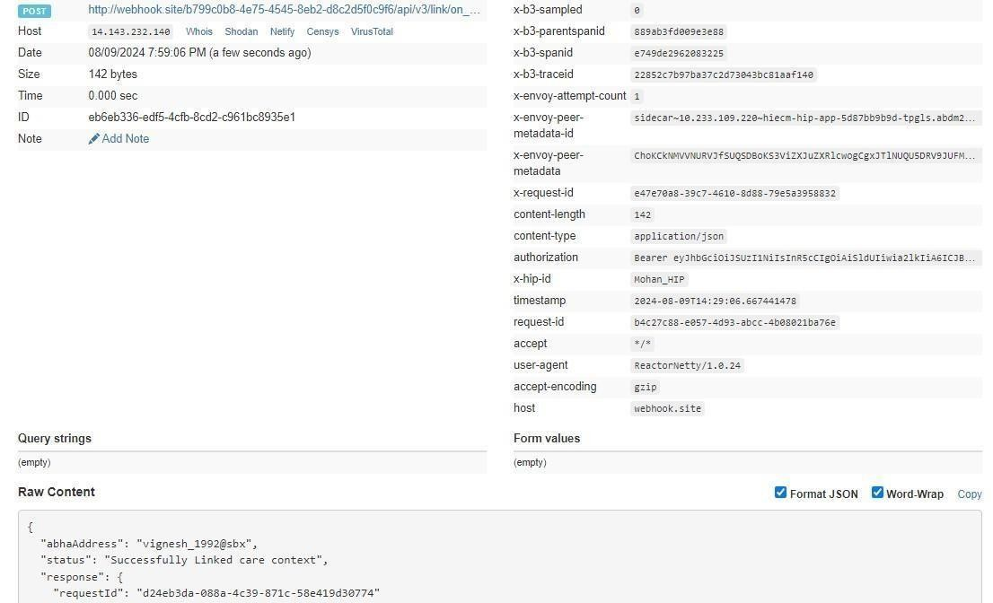

Call back HIU
All the HIUs who are subscribed will be notified about the linkage of care contexts.

4.3.5 Get all patient links

This is the PHR APP API, this api will used to fetch all link care-context for a patient.
URL: /api/hiecm/hip/v3/link/patient/links
Request: GET
Header Parameters:
Property  Name | Example Value | Required | Description
Authorization | eyJhbGciOiJSUzUxMiJ9. eyJzdWIiOiJ2 YXNhbnRoYWt1bWFyLmtlc2F2  YW5Ac2J4IiwiY2xpZW50SWQiOiJzYngi  LCJzeXN0ZW0iOiJBQkhBLUEiLCJy  ZXF1ZXN0ZXJJZCI6IlBIUi1XRUIiLCJwaHJ  Nb2JpbGUiOm51bGwsImV4c  CI6MTY2NzI5ODExNSwiaWF0IjoxNjY3Mj kwOTE1LCJwaHJBZ  GRyZXNzIjoidmFzYW50aGFrdW1hci5rZ  XNhdmFuQHNieCIsInR4bklkIjoi  YjEwMGM4ZDMtNTE1ZC00YWFiLTg1OW  QtYzNlMTUwOTE3ZGY1In0 | Yes | JWT Access token which was issued by ABDM session API after successful validation of client id and secret
REQUEST-ID | 18235d89-cb13-479d-ad71-  7a57d5f669a8 | Yes | Unique UUID for tracking the endtoend request transaction
TIMESTAMP | 2023 -03-09T07:07:41.793Z | Yes | The actual time when the request was initiated, ISO Date time format represents the date and time
X-AUTH-TOKEN | eyJhbGciOiJSUzUxMiJ9.eyJzdWIiOiJ2 YXNhbnRoYWt1bWFyLmtlc2F2 |  | JWT Authentication token which was issued by ABDM after successful validation of username and password
X-CM-ID | sbx | Yes | Suffix of the consent manager to which the request was intended

Request Params:

Property Name |  | Example Value | Description
limit | 100 |  | Number of records to be fetched from the database.
Error scenarios:

Scenarios | Headers/Body | Message
To verify when Request ID is Blank, null or empty in header | [  {  "key": "REQUEST-ID",  "value": "",  "type": "text"  } ] | Access Denied  Code : 403 Forbidden
 | [ | {
To verify when  invalid RequestID is pass in header | {  "key": "REQUEST-ID",  "value": "{{$guid}}zxzzxs",  "type": "text"  } ] | "code": "ABDM-1030: ", "message": "Invalid reque st ID"  }  Code: 400Bad Request
When  Timestamp is Blank, null or empty in header. | [  {  "key": "TIMESTAMP",  "value": "",  "type": "text"  } ] | Access Denied  Code : 403 Forbidden
When invalid  Timestamp is pass in header | [  {  "key": "TIMESTAMP",  "value": "{{$isoTimestamp}}jhgftytgtyu",  "type": "text"  } ] | {  "code": "ABDM-1016: ", "message": "Invalid Times tamp"  }  Code - 400Bad Request
Access Denied
Code : 403 Forbidden

When X-CM-ID | [ | Access Denied  Code : 403 Forbidden
is Invalid, Blank, null or empty in header. | {  "key": "X-CM-ID",  "value": "sbxdvdfvdf",  "type": "text"  }  ]
When X-Auth-  TOKEN is Invalid in header. | [  {  "key": "X-AUTH-TOKEN",  "value": "hghhjjkhjkbkjbjkbkjbnkjbk",  "type": "text"  } ] | {  ""code"": ""ABDM-1065: "",  ""message"": "" Invalid X  Auth token""  }  Code - 400Bad Request"

Response Body:
Response
{
"patient": {
"id": "user_1992@sbx",
"links": [
{
"hip": {
"id": "TestClinicHIP",
"name": "TestClinicHIP",
"type": "HIP" },
"referenceNumber": "user_1992@sbx",
"display": "User Record",
"hiType": "HealthDocumentRecord",
"careContexts": [
{
"referenceNumber": "e707c945-3672-4b85-8525-4c7e620ef301",
"display": "Visited on 08-Feb-2024 09:00:00 Visit Type as Out Patient"
}
],
"dateCreated": "2024-07-18T11:49:15.736Z"
}
]
}
}

4.3.6 Notify care context update

This API will be invoked by HIP after updating a health record to notify all the subscribed HIUs.
URL: /api/hiecm/hip/v3/link/context/notify
Request: POST
Header Parameters:
Property  Name | Example Value | Required | Description
Authorization | eyJhbGciOiJSUzUxMiJ9. eyJzdWIiOiJ2 YXNhbnRoYWt1bWFyLmtlc2F2  YW5Ac2J4IiwiY2xpZW50SWQiOiJzYngi  LCJzeXN0ZW0iOiJBQkhBLUEiLCJy  ZXF1ZXN0ZXJJZCI6IlBIUi1XRUIiLCJwaHJ  Nb2JpbGUiOm51bGwsImV4c  CI6MTY2NzI5ODExNSwiaWF0IjoxNjY3Mj kwOTE1LCJwaHJBZ  GRyZXNzIjoidmFzYW50aGFrdW1hci5rZ  XNhdmFuQHNieCIsInR4bklkIjoi  YjEwMGM4ZDMtNTE1ZC00YWFiLTg1OW  QtYzNlMTUwOTE3ZGY1In0 | Yes | JWT Access token which was issued by ABDM session API after successful validation of client id and secret
REQUEST-ID | 18235d89-cb13-479d-ad71-  7a57d5f669a8 | Yes | Unique UUID for tracking the endtoend request transaction
TIMESTAMP | 2023 -03-09T07:07:41.793Z | Yes | The actual time when the request was initiated, ISO Date time format represents the date and time
X-HIP-ID | IN2810014366 |  | Identifier of the health information provider to which the request was intended
X-CM-ID | sbx | Yes | Suffix of the consent manager to which the request was intended
Body Parameters:
Property Name | Example Value | Required | Description
Patient | “patient” : {  “id”: “user123@sbx”  } | Yes | The abha address of the patient whose record was updated.
careContext | "careContext": {  "patientReference": "batman@tmh",  "careContextReference":  "Episode1"  } | Yes | Updated health record of the patient.
hiTypes | "hiTypes": [  "OPConsultation"  ] | Yes | There are 7 different hiTypes in ABDM:  Prescription  DiagnosticReport  OPConsultation  DischargeSummary  ImmunizationRecord  HealthDocumentRecord  WellnessRecord
Date | “2024-05-30T05:21:34.155Z” | Yes | The UTC time when the request was initiated, ISO Date time format represents the date and time.
Hip | "hip": {  "id": "demo-hip-261222"  } | Yes | Identifier of the health information provider.

Request Body:

Request Body:
{
"notification": {
"patient": {
"id": "user_122@sbx"
},
"careContext": {
"patientReference": "batman@tmh",
"careContextReference": "Episode1"
},
"hiTypes": [
"OPConsultation"
],
"date": "2024-05-30T05:21:34.155Z",
"hip": {
"id": "demo-hip-261222"
} } }

Error scenarios:

Scenarios | Headers/Body | Message
To verify when Request ID is Blank, null or empty in header | [  {  "key": "REQUEST-ID",  "value": "",  "type": "text"  } ] | Access Denied  Code : 403 Forbidden
To verify when  invalid RequestID is pass in header | [  {  "key": "REQUEST-ID",  "value": "{{$guid}}zxzzxs",  "type": "text"  } ] | {  "code": "ABDM-1030: ", "message": "Invalid requ est ID"  }  Code: 400Bad Request
When Timestamp is Blank, null or empty in header. | [  {  "key": "TIMESTAMP",  "value": "",  "type": "text"  } ] | Access Denied  Code : 403 Forbidden
When invalid  Timestamp is pass in header | [  {  "key": "TIMESTAMP",  "value": "{{$isoTimestamp}}jhgftytgtyu",  "type": "text"  } ] | {  "code": "ABDM-1016: ", "message": "Invalid Time stamp"  }  Code - 400Bad Request
Access Denied
Code : 403 Forbidden

When X-CM-ID  is Invalid, Blank, null or empty in header. | [  {  "key": "X-CM-ID",  "value": "sbxdvdfvdf", | Access Denied
 |  | Code : 403 Forbidden
 | "type": "text"
 | }
 | ]
When X-HIP-ID is empty or Invalid in header. | [  {  "key": " X-HIP-ID",  "value": "",  "type": "text"  } | Access Denied  Code : 403 Forbidden
 | ]
When given XHIP-ID does not exist. |  | {  "code": "ABDM-1035: ",  "message": "Invalid HIP  ID" }
Response Body:
Response
Code : 202 Accepted

Call back HIU

All the HIUs who are subscribed will be notified about the linkage of care contexts.

4.3.7 Call back API for notify care context update
This is a callback API triggered by HIE-CM to notify HIP/HRP about care context update response.
URL: {callbackURL}/api/v3/links/context/on-notify Request: POST Header Parameters:
Property  Name | Example Value | Required | Description
Authorization | eyJhbGciOiJSUzUxMiJ9. eyJzdWIiOiJ2 YXNhbnRoYWt1bWFyLmtlc2F2  YW5Ac2J4IiwiY2xpZW50SWQiOiJzYngi  LCJzeXN0ZW0iOiJBQkhBLUEiLCJy  ZXF1ZXN0ZXJJZCI6IlBIUi1XRUIiLCJwaHJ  Nb2JpbGUiOm51bGwsImV4c  CI6MTY2NzI5ODExNSwiaWF0IjoxNjY3Mj kwOTE1LCJwaHJBZ  GRyZXNzIjoidmFzYW50aGFrdW1hci5rZ  XNhdmFuQHNieCIsInR4bklkIjoi  YjEwMGM4ZDMtNTE1ZC00YWFiLTg1OW  QtYzNlMTUwOTE3ZGY1In0 | Yes | JWT Access token which was issued by ABDM session API after successful validation of client id and secret
REQUEST-ID | 18235d89-cb13-479d-ad71-  7a57d5f669a8 | Yes | Unique UUID for tracking the endto-end request transaction
TIMESTAMP | 2023 -03-09T07:07:41.793Z | Yes | The actual time when the request was initiated, ISO Date time format represents the date and time
X-HIP-ID | IN2810014366 |  | Identifier of the health information provider to which the request was intended
Body Parameters:
Property Name | Example Value | Required | Description
requestId | 18235d89-cb13-  479dad717a57d5f669a8 | Yes | Unique UUID for tracking the end-toend request transaction
timestamp | 2023 -03-09T07:07:41.793Z | Yes | The actual UTC time when the request was initiated, ISO Date time format represents the date and time
error | "error": {  "code": "ABDM-1024",  "message": "Dependent service unavailable"  } | No | The error code and message if the notify request is failed.
response | “response“: {  “requestId”: “18235d89-cb13- 479d-ad71-7a57d5f6656a”  } | Yes | requestId from the  /api/hiecm/hip/v3/link/context/notify API call
acknowledgement | " acknowledgement": {  “status": “SUCCESS"  } | Yes | Status of the  /api/hiecm/hip/v3/link/context/notify API call.

Request Body:
{
"requestId": "743ec386-670f-43a8-a3ed-44aa30fb15fb",
"timestamp": "2024-05-09T10:34:00.387Z",
"acknowledgement": {
"status": "SUCCESS"
},
"response": {
"requestId": "6f0b4665-a915-4c92-aa36-65afb4a2cd71"
}
}
Response Body:
Response
Code : 202 Accepted

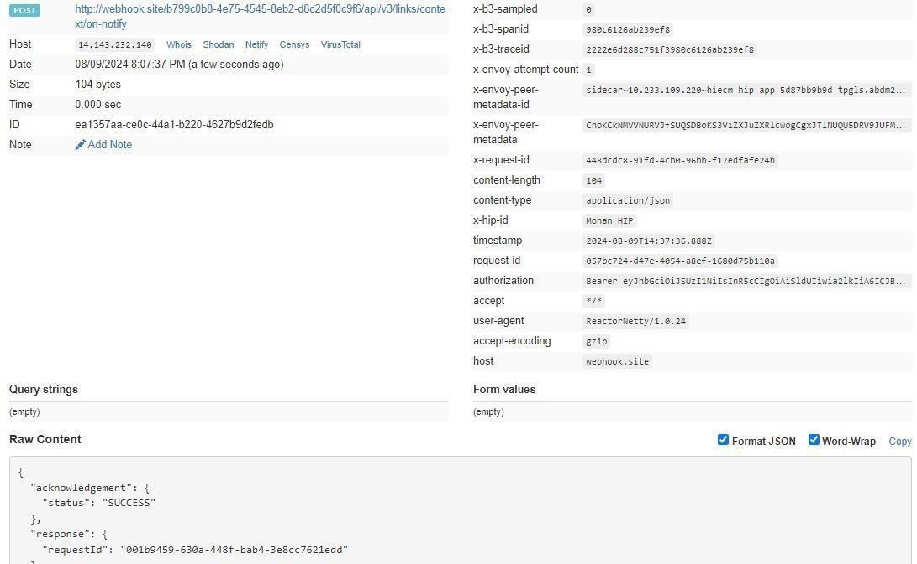

4.3.8 SMS Notification to patients

This API will be invoked by HIP to trigger a SMS notification to the patient mobile number when health record is available to fetch.

URL: /api/hiecm/hip/v3/link/patient/links/sms/notify2
Request: POST
Header Parameters:
Property  Name | Example Value | Required | Description
Authorization | eyJhbGciOiJSUzUxMiJ9. eyJzdWIiOiJ2 YXNhbnRoYWt1bWFyLmtlc2F2  YW5Ac2J4IiwiY2xpZW50SWQiOiJzYngi  LCJzeXN0ZW0iOiJBQkhBLUEiLCJy  ZXF1ZXN0ZXJJZCI6IlBIUi1XRUIiLCJwaHJ Nb2JpbGUiOm51bGwsImV4c  CI6MTY2NzI5ODExNSwiaWF0IjoxNjY3Mj kwOTE1LCJwaHJBZ  GRyZXNzIjoidmFzYW50aGFrdW1hci5rZ  XNhdmFuQHNieCIsInR4bklkIjoi  YjEwMGM4ZDMtNTE1ZC00YWFiLTg1OW  QtYzNlMTUwOTE3ZGY1In0 | Yes | JWT Access token which was issued by ABDM session API after successful validation of client id and secret
REQUEST-ID | 18235d89-cb13-479d-ad71-  7a57d5f669a8 | Yes | Unique UUID for tracking the endtoend request transaction
TIMESTAMP | 2023 -03-09T07:07:41.793Z | Yes | The actual time when the request was initiated, ISO Date time format represents the date and time
X-CM-ID | sbx | Yes | Suffix of the consent manager to which the request was intended
Body Parameters:
Property Name | Example Value | Required | Description
requestId | 18235d89-cb13-479d-ad71-  7a57d5f669a8 | Yes | The id will be unique value to identify each notification requests.
phoneNo | 9876543210 | Yes | Mobile number of the patient.
hip | "hip": {  "name": "HIP Name",  "id": "TestClinicHIP"  } | Yes | Identifier and name of the health information provider.

Request Body:

Request Body:
{
"requestId": "743ec386-670f-43a8-a3ed-44aa30fb15fb",
"timestamp": "2024-05-09T10:34:00.387Z",
"notification": {
"phoneNo": "986543210",
"hip": {
"id": "ABDM_HIP",
"name": "ABC Hospital"
}
} }

Error scenarios:

Scenarios | Headers/Body | Message

To verify when Request ID is Blank, null or | [  {  "key": "REQUEST-ID", | Access Denied  Code : 403 Forbidden
empty in  header | "value": "",  "type": "text"  } ]
To verify when  invalid RequestID is pass in header | [  {  "key": "REQUEST-ID",  "value": "{{$guid}}zxzzxs",  "type": "text"  } ] | {  "code": "ABDM-1030: ", "message": "Invalid requ est ID"  }  Code: 400Bad Request
When  Timestamp is  Blank, null or empty in header. | [  {  "key": "TIMESTAMP",  "value": "",  "type": "text"  } ] | Access Denied  Code : 403 Forbidden
When invalid Timestamp is pass in header | [  {  "key": "TIMESTAMP",  "value": "{{$isoTimestamp}}jhgftytgtyu",  "type": "text"  } ] | {  "code": "ABDM-1016: ", "message": "Invalid Time stamp"  }  Code - 400Bad Request
Access Denied
Code : 403 Forbidden

When X-CM-ID  is Invalid, Blank, null or empty in header. | [  {  "key": "X-CM-ID",  "value": "sbxdvdfvdf",  "type": "text"  }  ] | Access Denied
 |  | Code : 403 Forbidden
When given HIP id does not exist. |  | {  "code": "ABDM-1035: ", "message": "Invalid HIP  ID" }
Response Body:
Response
Code : 202 Accepted

4.3.9 Callback API for SMS Notification to patients

This is a callback API triggered by HIE-CM to notify HIP/HRP about SMS notification response. URL: {callbackURL}/api/v3/patients/sms/on-notify
Request: POST Header Parameters:
Property  Name | Example Value | Required | Description
Authorization | eyJhbGciOiJSUzUxMiJ9. eyJzdWIiOiJ2 YXNhbnRoYWt1bWFyLmtlc2F2  YW5Ac2J4IiwiY2xpZW50SWQiOiJzYngi  LCJzeXN0ZW0iOiJBQkhBLUEiLCJy  ZXF1ZXN0ZXJJZCI6IlBIUi1XRUIiLCJwaHJ  Nb2JpbGUiOm51bGwsImV4c  CI6MTY2NzI5ODExNSwiaWF0IjoxNjY3Mj kwOTE1LCJwaHJBZ  GRyZXNzIjoidmFzYW50aGFrdW1hci5rZ  XNhdmFuQHNieCIsInR4bklkIjoi  YjEwMGM4ZDMtNTE1ZC00YWFiLTg1OW  QtYzNlMTUwOTE3ZGY1In0 | Yes | JWT Access token which was issued by ABDM session API after successful validation of client id and secret
REQUEST-ID | 18235d89-cb13-479d-ad71-  7a57d5f669a8 | Yes | Unique UUID for tracking the endto-end request transaction
TIMESTAMP | 2023 -03-09T07:07:41.793Z | Yes | The actual time when the request was initiated, ISO Date time format represents the date and time
X-HIP-ID | IN2810014366 | Yes | Identifier of the health information provider to which the request was intended
Body Parameters:
Property  Name | Example Value | Required | Description
requestId | 18235d89-cb13-  479dad717a57d5f669a8 | Yes | Unique UUID for tracking the end-to-end request transaction
timestamp | 2023 -03-09T07:07:41.793Z | Yes | The actual UTC time when the request was initiated, ISO Date time format represents the date and time
status | “status": “SUCCESS" | Yes | Status of the  /hiecm/api/v3/link/patient/links/sms/notify2  API call.
error | "error": {  "code": "ABDM-1024",  "message": "Dependent service unavailable"  } | No | The error code and message if the notify request is failed.
resp | “resp“: {  “requestId”: “18235d89cb13-  479d-ad717a57d5f6656a”  } | Yes | requestId from the  /hiecm/api/v3/link/patient/links/sms/notify2  API call.

Request Body:

Request Body:
{
"requestId": "743ec386-670f-43a8-a3ed-44aa30fb15fb",
"timestamp": "2024-05-09T10:34:00.387Z",
"status": "SUCCESS",
"error": {
"code": "ABDM-1024",
"message": "Dependent service unavailable"
},
"resp": {
"requestId": "6f0b4665-a915-4c92-aa36-65afb4a2cd71"
} }

Response Body:
Response
Code : 202 Accepted

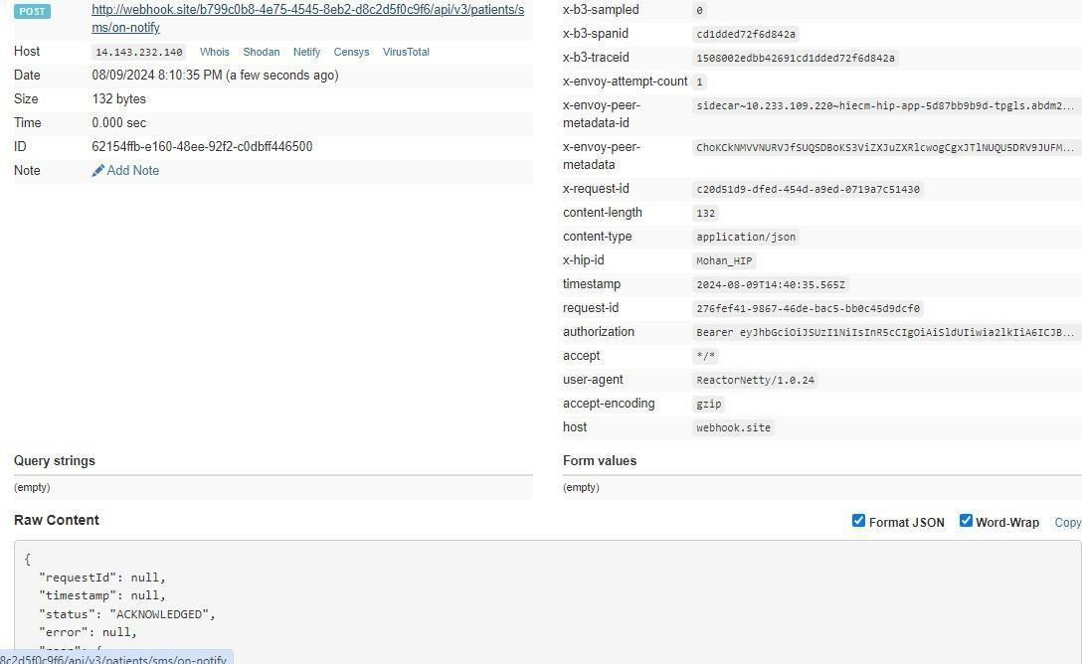

5.User Initiated Linking

5.1 Overview

User-initiated linking is the process in which Users/Patient search for their health records from ABDM-compliant health facilities. Once health records are found, users can link their health records with their ABHA address.

The user must have a Patient HIU (PHR App in the current scenario) via which the user can start the discovery of health records and link the health records for future reference.

Following are the steps involved in User initiated linking
- User searches for a health facility that they have visited in the past.
- The health facility must be a HIP (part of the facility registry) and linked with an HRP for discovery to be supported
- User makes a discovery request via Patient HIU (PHR App) – i.e., requests the HIP to find any health records in their name
- User shares his/her details through their PHR address. Details shared- Name, Date of birth, Gender, verified mobile no. with the HIP / HRP
- The HRP/HIP is expected to search its database for any records that match this patient.
- If there is a match, the HRP/HIP returns with the Care Context details for the records available
- If there is no match, the HRP/HIP returns an error
- The User can now request to link the records (care contexts) with their PHR address
- The HRP/HIP will perform the validation by sending an OTP to the registered mobile.
- If the authentication succeeds, the care contexts are linked to the PHR address

5.2 Sequence Diagram

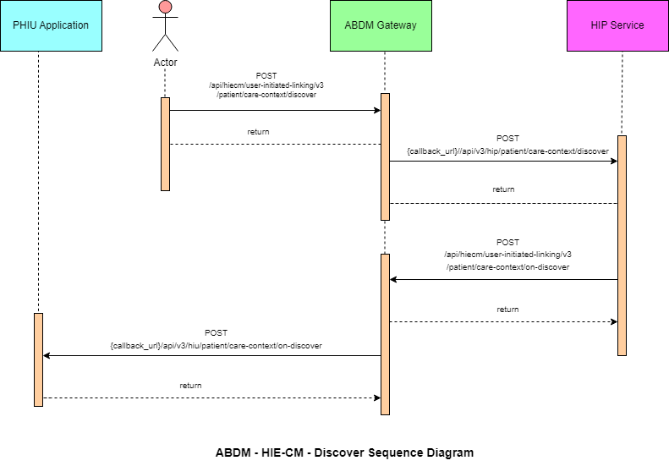

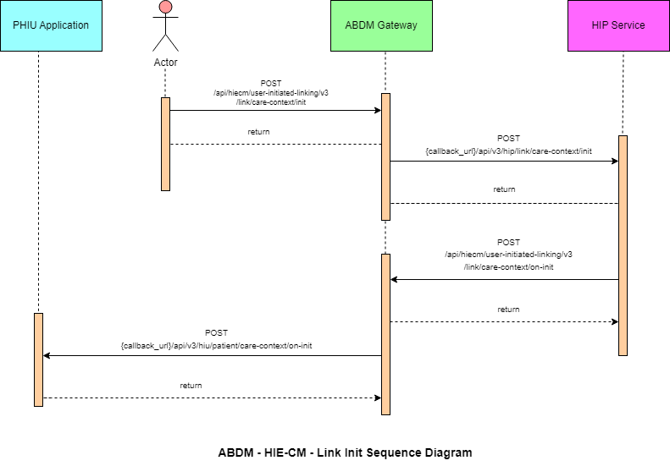

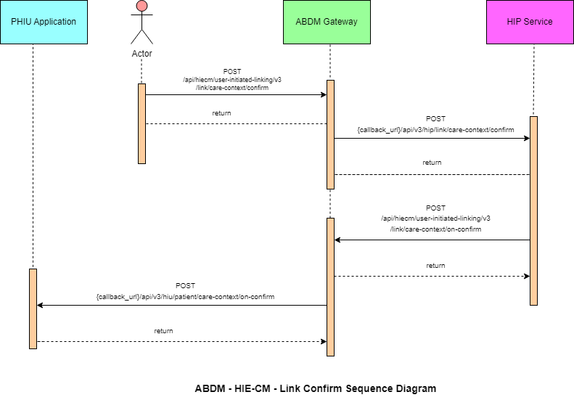

5.3List of APIs

5.3.1 Patient Health record discovery
This API will be invoked by the patient/user from the PHR application to HIECM to discover his/her health records.
URL: /api/hiecm/user-initiated-linking/v3/patient/care-context/discover Request: POST Header Parameters:
Property  Name | Example Value | Required | Description
Authorization | eyJhbGciOiJSUzUxMiJ9. eyJzdWIiOiJ2 YXNhbnRoYWt1bWFyLmtlc2F2  YW5Ac2J4IiwiY2xpZW50SWQiOiJzYngi  LCJzeXN0ZW0iOiJBQkhBLUEiLCJy  ZXF1ZXN0ZXJJZCI6IlBIUi1XRUIiLCJwaHJ Nb2JpbGUiOm51bGwsImV4c  CI6MTY2NzI5ODExNSwiaWF0IjoxNjY3Mj kwOTE1LCJwaHJBZ  GRyZXNzIjoidmFzYW50aGFrdW1hci5rZ  XNhdmFuQHNieCIsInR4bklkIjoi  YjEwMGM4ZDMtNTE1ZC00YWFiLTg1OW  QtYzNlMTUwOTE3ZGY1In0 | Yes | JWT Access token which was issued by ABDM session API after successful validation of client id and secret
REQUEST-ID | 18235d89-cb13-479d-ad71-  7a57d5f669a8 | Yes | Unique UUID for tracking the end-toend request transaction
TIMESTAMP | 2023 -03-09T07:07:41.793Z | Yes | The actual time when the request was initiated, ISO Date time format represents the date and time
X-AUTH-TOKEN | eyJhbGciOiJSUzUxMiJ9.eyJzdWIiOiJ2 YXNhbnRoYWt1bWFyLmtlc2F2 |  | JWT Authentication token which was issued by ABDM after  successful validation of username and password
X-CM-ID | sbx | Yes | Suffix of the consent manager to which the request was intended
X-HIU-ID | HIU_ID | Yes | Identifier of the health information user to which the request was intended

Body Parameters:
Property Name | Example Value | Required | Description
hipId | ABDM_HIP | Yes | Identifier of the health information provider to which the request was intended
unverifiedIdentifiers | {  "type": "ABHA_ADDRESS",  "value": "shaik.XXXX@sbx"  } | Yes | Identifiers using which the HIP will search the patient information in their records.

Request Body:

Request Body
{
"hipId": "ABDM_HIP",
"unverifiedIdentifiers": [
{
"type": "ABHA_ADDRESS",
"value": "shaik.XXXX@sbx"
} ]
}

Response Body:
Response
Code: 202 Accepted

Error scenarios:

Scenarios | Headers/Body | Message
To verify when Request ID is Blank, null or empty in header | [  {  "key": "REQUEST-ID",  "value": "",  "type": "text"  } ] | Access Denied  Code : 403 Forbidden
To verify when  invalid RequestID is pass in header | [  {  "key": "REQUEST-ID",  "value": "{{$guid}}zxzzxs",  "type": "text"  } ] | {  "code": "ABDM-1030: ", "message": "Invalid reque st ID"  }  Code: 400Bad Request

When Timestamp is Blank, null or empty in header. | [  {  "key": "TIMESTAMP",  "value": "",  "type": "text"  } ] | Access Denied  Code : 403 Forbidden
When invalid Timestamp is pass in header | [  {  "key": "TIMESTAMP",  "value": "{{$isoTimestamp}}jhgftytgtyu",  "type": "text"  } ] | {  "code": "ABDM-1016: ", "message": "Invalid Times tamp"  }  Code - 400Bad Request
When X-HIP-ID is Blank, null or empty in header. | [  {  "key": "X-HIP-ID",  "value": "",  "type": "text"  } ] | Access Denied  Code : 403 Forbidden
When X-CM-ID  is Invalid, Blank, null or empty in header. | [  {  "key": "X-CM-ID",  "value": "sbxdvdfvdf", | Access Denied
 |  | Code : 403 Forbidden
 | "type": "text"
}
]
When X-Auth-  TOKEN is Invalid in header. | [  {  "key": "X-LINK-TOKEN",  "value": "hghhjjkhjkbkjbjkbkjbnkjbk",  "type": "text"  } ] | {  ""code"": ""ABDM-1066: "", ""message"": ""Invalid JWT token""  }  Code - 400Bad Request"
Verify when HIP is null, blank or invalid in the body | {  "hip": {  "id": ""  },  "unverifiedIdentifiers": [  {  "type": "MR",  "value": "69128688344"  }  ] } | {  "code": "ABDM-9999: ",  "message": "HIP ID is mandatory"  }
When X-HIU-ID and the hipId in the payload is same. |  | {  ""code"": ""ABDM-1031  : "",  ""message"": HIP and HIU cannot be same""  }  Code - 400Bad Request"
When duplicate request payload is sent. |  | {  "code": "ABDM-1103: ",  ""message"": “Duplicate Discovery request“  }  Code - 400Bad Request"

5.3.2 HIE-CM callback to HIP - Discovery
This is a callback API invoked by HIE-CM to let the HIP know about the discovery request raised by the patient using HIE-CM’s discovery.
URL: {callback_url}/api/v3/hip/patient/care-context/discover
Request: POST
Header Parameters:
Property  Name | Example Value | Required | Description
REQUEST-ID | 18235d89-cb13-479d-ad71-7a57d5f669a8 | Yes | Unique UUID for tracking the endto-end request transaction
TIMESTAMP | 2022-10-06T10:10:00.587Z | Yes | The actual time when the request was initiated, ISO Date time format represents the date and time
X-HIP-ID | HIP_ID | Yes | Identifier of the health information provided to which the request was intended

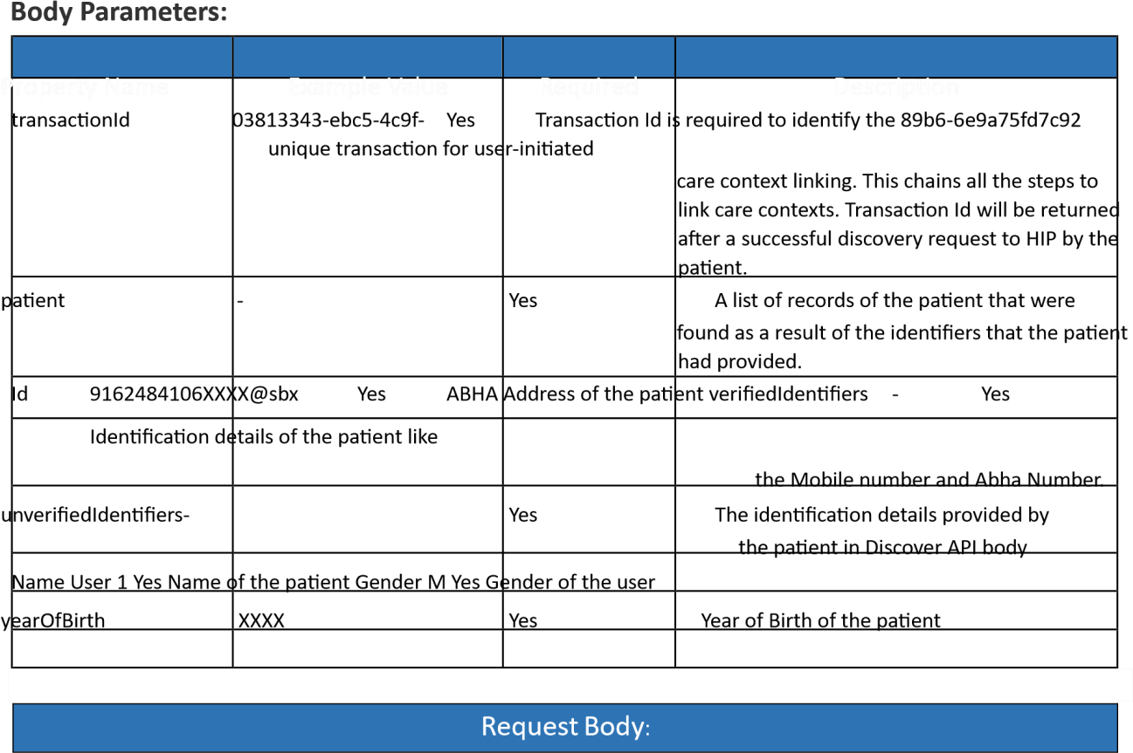
{
"transactionId": "03813343-ebc5-4c9f-89b6-6e9a75fd7c92",
"patient": {
"id": "9167@sbx",
"verifiedIdentifiers": [
{
"type": "MOBILE",
"value": "987654XXXX"
},
{
"type": "ABHA_NUMBER",
"value": "916248419XXXX"
}
],
"unverifiedIdentifiers": [
{
"type": "MR",
"value": "987654XXXX"
}
],
"name": "User 1",
"gender": "M",
"yearOfBirth": XXXX
} }

Response
Code: 200 OK

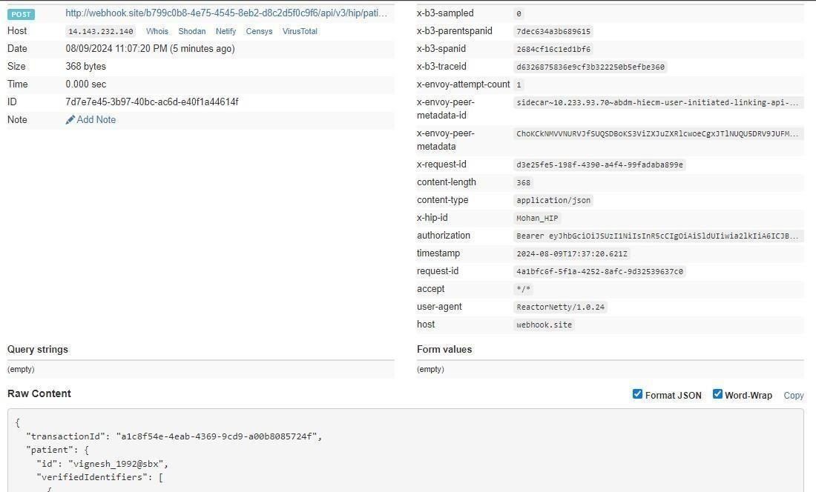

5.3.3 HMIS/LMIS response on health record discover

This API will be invoked by the HMIS/LIMS application for sharing the response of discover request.
URL: /api/hiecm/user-initiated-linking/v3/patient/care-context/on-discover
Request: POST
Header Parameters:
Property  Name | Example Value | Required | Description
Authorization | eyJhbGciOiJSUzUxMiJ9. eyJzdWIiOiJ2YXNhbnRoY Wt1bWFyLmtlc2F2YW5Ac2J4IiwiY2xpZW50SWQiOi JzYngiLCJzeXN0ZW0iOiJBQkhBLUEiLCJyZXF1ZXN0Z XJJZCI6IlBIUi1XRUIiLCJwaHJNb2JpbGUiOm51bGw sImV4cCI6MTY2NzI5ODExNSwiaWF0IjoxNjY3Mjkw OTE1LCJwaHJBZGRyZXNzIjoidmFzYW50aGFrdW1h ci5rZXNhdmFuQHNieCIsInR4bklkIjoiYjEwMGM4ZD MtNTE1ZC00YWFiLTg1OWQtYzNlMTUwOTE3ZGY1In0 | Yes | JWT Access token which was issued by ABDM session API after successful validation of client id and secret
REQUEST-ID | 18235d89-cb13-479d-ad71-7a57d5f669a8 | Yes | Unique UUID for tracking the end-toend request transaction
TIMESTAMP | 2022-10-06T10:10:00.587Z | Yes | The actual time when the request was initiated, ISO Date time format represents the date and time
X-CM-ID | sbx | Yes | Suffix of the consent manager to which the request was intended
Body Parameters:
Property  Name | Example Value | Required | Description
transactionId | f901b782-bfdf-4224-  9f8d-da2cadc20c0d | Yes | Transaction Id is required to identify the unique transaction for user-initiated care context linking.  This chains all the steps to link care contexts. Transaction Id will be returned after a successful discovery request to HIP by the patient.
patient | - | Optional | A list of records of the patient that were found as a result of the identifiers that the patient had provided.
referenceNumber | example01 | Yes | Reference number of the patient details
careContexts | - | Yes | List of care contexts linked at the HIP end for the identified patient.
hiType | PRESCRIPTION | Yes | HiType of the patient details
count | 1 | Yes | The count of care contexts that are found for the patient in scope
requestId | 2c17a46b-d28e-  4a60a7cffe77163ae93c | Yes | Request ID sent by the patient in the discovery API call. This request ID will be used to match the flow of linking care contexts for a patient
Error | {  "code": "ABDM-1010", "message": "Patient not  found"  } | Optional | The error should be included if no details are found for the patient at HIP for the given patient identifiers. The error should contain ABDM standard code and message to indicate the reason properly.
matchedBy | MR | Yes | How the records are matched

Request Body
Success Scenario:
{
"transactionId": "66446ece-396b-4f22-a1a6-756196fdffc9",
"patient": [
{
"referenceNumber": "example01",
"display": "abcd-display",
"careContexts": [
{
"referenceNumber": "abcd",
"display": "123-display"
}
],
"hiType": "PRESCRIPTION",
"count": 1
}
],
"matchedBy": [
"MR"
],
"response": {
"requestId": "2c17a46b-d28e-4a60-a7cf-fe77163ae93c"
} }
Failure Scenario:
{
"transactionId": "66446ece-396b-4f22-a1a6-756196fdffc9",
"error": {
"code": "ABDM-1010",
"message": "Patient not found"
},
"response": {
"requestId": "2c17a46b-d28e-4a60-a7cf-fe77163ae93c"
} }

Response:

Response
Code: 202 Accepted
Error Scenarios:

Scenarios | Headers/Body | Message
To verify when Request ID is Blank, null or empty in header | [  {  "key": "REQUEST-ID",  "value": "",  "type": "text"  } ] | Access Denied  Code : 403 Forbidden
To verify when invalid  Request-ID is pass in header | [  {  "key": "REQUEST-ID",  "value": "{{$guid}}zxzzxs",  "type": "text"  } ] | {  "code": "ABDM-1030: ",  "message": "Invalid request I D"  }  Code: 400Bad Request
When Timestamp is Blank, null or empty in header. | [  {  "key": "TIMESTAMP",  "value": "",  "type": "text"  } ] | Access Denied  Code : 403 Forbidden
When invalid Timestamp is pass in header | [  {  "key": "TIMESTAMP",  "value": "{{$isoTimestamp}  }jhgftytgtyu",  "type": "text"  } ] | {  "code": "ABDM-1016: ", "message": "Invalid Timesta mp"  }  Code - 400Bad Request
When X-CM-ID is Invalid, Blank, null or empty in header. | [  {  "key": "X-CM-ID",  "value": "sbxdvdfvdf",  "type": "text"  } ] | Access Denied  Code : 403 Forbidden

Verify when transaction id is invalid, null or blank | "transactionId": "776a9becab12-  42bc-9ae9c63b1ae5bce2",  "patient": [  {  "referenceNumber": "ST1",  "display": "",  "careContexts": [  {  "referenceNumber": "S T2",  "display": "ST2"  }  ],  "hiType": "PRESCRIPTION",  "count": 1  }  ],  "matchedBy": [  "MR"  ],  "response": {  "requestId": "6f37ddf8-62df-  4 afe-bc25-599789c90558" | "code": "ABDM-9999: ",  "message": "Invalid Transactio n ID / Transaction expired."
Verify message when HI types is passed as incorrect | "transactionId": "776a9becab12-  42bc-9ae9c63b1ae5bce2",  "patient": [  {  "referenceNumber": "ST1",  "display": "",  "careContexts": [  {  "referenceNumber": "S T2",  "display": "ST2"  }  ],  "hiType": "PRESCRIPTION",  "count": 1  }  ],  "matchedBy": [  "MR"  ],  "response": {  "requestId": "6f37ddf8-  62df4afebc25-599789c90558" | {  "code": "ABDM-9999: ",  "message": "Invalid HIType, it must be in PRESCRIPTION, DIAGNOSTI  CREPORT,  OPCONSULTATION, DISCHARGES  UMMARY,  IMMUNIZATIONRECORD, HEALTH  DOCUMENTRECORD, WELLNESSR  ECORD"  }  400 Bad Request

Verify message when careconexts is blank, null | "transactionId": "776a9becab12-  42bc-9ae9c63b1ae5bce2",  "patient": [  {  "referenceNumber": "ST1",  "display": "",  "careContexts": [  {  "referenceNumber": "S T2",  "display": "ST2"  }  ],  "hiType": "PRESCRIPTION",  "count": 1  }  ],  "matchedBy": [  "MR"  ],  "response": {  "requestId": "6f37ddf8-62df-  4 afe-bc25-599789c90558" | {  "code": "ABDM-9999: ",  "message": "Invalid Care  Contexts count, must range be tween  1 to 20"  }
Verify if the requestId is a valid id from the discovery request. |  | {  "code": "ABDM-1015: ",  "message": "Invalid  Response"  }

Verify if it is a duplicate request |  | {  "code": "ABDM-1106: ", "message": "Duplicate On discovery request"  }  Code: 400Bad Request
Verify if the count and the no of care contexts matches in the payload. | "transactionId": "776a9becab12-  42bc-9ae9c63b1ae5bce2",  "patient": [  {  "referenceNumber": "ST1",  "display": "",  "careContexts": [  {  "referenceNumber": "S T2",  "display": "ST2"  }  ],  "hiType": "PRESCRIPTION",  "count": 2  }  ],  "matchedBy": [  "MR"  ],  "response": {  "requestId": "6f37ddf8-  62df4afebc25-599789c90558" | {  "code": "ABDM-1059: ",  "message": "Invalid Care  Contexts count"  }

5.3.4 HIE-CM callback on Health record discover
This API will be invoked by the HIE-CM for sharing the response of health record discover.

URL: {callback_url}/api/v3/hiu/patient/care-context/on-discover Request: POST
Header Parameters:
Property Name | Example Value | Required | Description
REQUEST-ID | 18235d89-cb13-479d-ad71-  7a57d5f669a8 | Yes | Unique UUID for tracking the endto-end request transaction
TIMESTAMP | 2022-10-06T10:10:00.587Z | Yes | The actual time when the request was initiated, ISO Date time format represents the date and time
X-CM-ID | sbx | Yes | Identifier of the health information user to which the request was intended
Body Parameters:
Property Name | Example Value | Required | Description
transactionId | f901b782bfdf4224-  9f8dda2cadc20c0d | Yes | Transaction Id is required to identify the unique transaction for user-initiated care context linking.  This chains all the steps to link care contexts. Transaction Id will be returned after a successful discovery request to HIP by the patient.
patient | - | Yes | A list of records of the patient that were found as a result of the identifiers that the patient had provided.
referenceNumber | example01 | Yes | Reference number of the patient details
careContexts | - | Yes | List of care contexts linked at the HIP end for the identified patient.
hiType | PRESCRIPTION | Yes | HiType of the patient details
Count | 1 | Yes | The count of care contexts that are found for the patient in scope
createdAt | 2023-06-  13T08:05:43.030Z | Yes | The time at which the on discover API is invoked
requestId | d89525a23a3f-  4d39-  98b5-  477afb1865f6 | Yes | Request ID sent by in on-discover API call. This request ID will be used to match the flow of linking care contexts for a patient
Request Body:
Request Body:
{
"transactionId": "0d36501c-551a-4bb5-b247-eec4bb42984b",
"patient": [
{
"referenceNumber": "example01",
"display": "abcd-display",
"careContexts": [
{
"referenceNumber": "abcd",
"display": "123-display"
}
],
"hiType": "PRESCRIPTION",
"count": 1
}
],
"createdAt": "2023-06-13T08:05:43.030Z",
"response": {
"requestId": "d89525a2-3a3f-4d39-98b5-477afb1865f6"
}
}

Response:

Response
Code: 200 OK

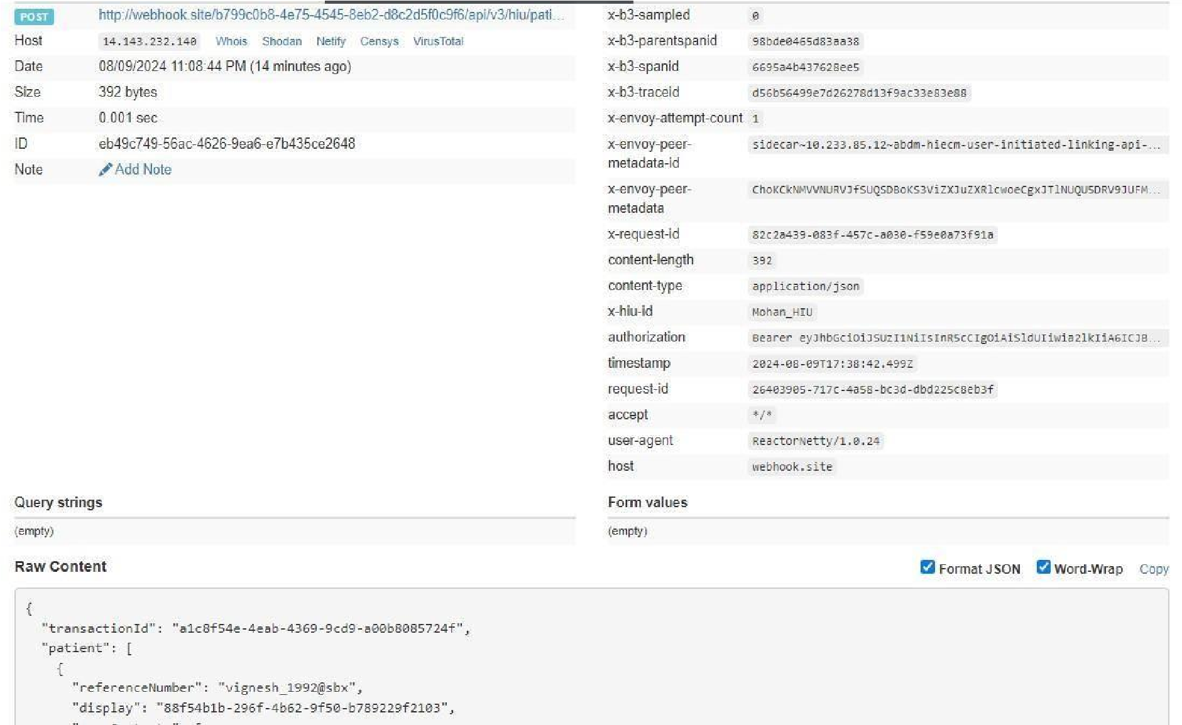

Error response:

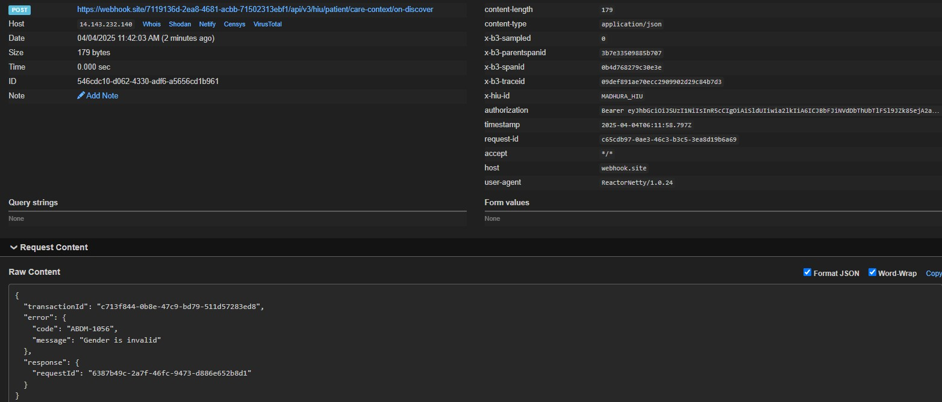

5.3.5 Patient health record link init
This API will be invoked by the patient to link his/her health records.

URL: /api/hiecm/user-initiated-linking/v3/link/care-context/init
Request: POST
Header Parameters:
Property Name | Example Value | Required | Description
Authorizatio  n | eyJhbGciOiJSUzUxMiJ9. eyJzdWIiOiJ2YX NhbnRoYWt1bWFyLmtlc2F2YW5Ac2J4Ii wiY2xpZW50SWQiOiJzYngiLCJzeXN0ZW 0iOiJBQkhBLUEiLCJyZXF1ZXN0ZXJJZCI6Il BIUi1XRUIiLCJwaHJNb2JpbGUiOm51bGw sImV4cCI6MTY2NzI5ODExNSwiaWF0Ijox NjY3MjkwOTE1LCJwaHJBZGRyZXNzIjoid mFzYW50aGFrdW1hci5rZXNhdmFuQHNi eCIsInR4bklkIjoiYjEwMGM4ZDMtNTE1ZC0 0YWFiLTg1OWQtYzNlMTUwOTE3ZGY1In0 | Yes | JWT Access token which was issued by ABDM session API after successful validation of client id and secret
REQUEST-ID | 18235d89-cb13-479d-ad71-  7a57d5f669a8 | Yes | Unique UUID for track the end-toend request transaction
TIMESTAMP | 2022-10-06T10:10:00.587Z | Yes | Actual time when request was initiated,  ISO Date time format represents date and time
X-AUTHTOKEN | eyJhbGciOiJSUzUxMiJ9.eyJzdWIiOiJ2 YXNhbnRoYWt1bWFyLmtlc2F2 |  | JWT Authentication token which was issued by ABDM after successful validation of username and password
X-HIU-ID | HIU_ID | Yes | Identifier of the health information user by which the request was initiated
X-CM-ID | sbx | Yes | Suffix of the consent manager to which the request was intended
Body Parameters:
Property Name | Example Value | Required | Description
transactionId | f901b782bfdf4224-  9f8dda2cadc20c0d | Yes | Transaction Id is required to identify the unique transaction for user-initiated care context linking. This chains all the steps to link care contexts. Transaction Id will be returned after successful discovery request to HIP by the patient.
abhaAddress | user_123@sbx | No | The abha address of the patient
patient | - | Yes | A list of records of the patient that were found as a result of the identifiers that the patient had provided.
referenceNumber | example01 | Yes | Reference number of the patient details
careContexts | - | Yes | List of care contexts linked at the HIP end for the identified patient.
hiType | PRESCRIPTION | Yes | HiType of the patient details
Count | 1 | Yes | The count of care contexts that are found for the patient in scope

Request Body:
Request Body:
{
"transactionId": "66446ece-396b-4f22-a1a6-756196fdffc9",
"abhaAddress": "user_123@sbx",
"patient": [
{
"referenceNumber": "example01",
"careContexts": [
{
"referenceNumber": "123"
}
],
"hiType": "PRESCRIPTION",
"count": 1
} ]
}
Response:
Response
Code : 202 Accepted

Error scenarios:

Scenarios | Headers/Body | Message
Verify when transaction id is invalid, null or blank | "transactionId": "",  "error": {  "code": "ABDM-1010", "message": "test"  },  "response": {  "requestId": "926ca4adaef54937a26cc2b529464566"  } | "code": "ABDM-9999: ",  "message" : "Invalid Transaction ID"

Verify message when count is incorrect | "transactionId": "776a9becab1242bc9ae9c63b1ae5bce2",  "patient": [  {  "referenceNumber": "Testing defect",  "careContexts": [  {  "referenceNumber": "1234",  "display": "12"  } ],  "hiType": "PRESCRIPTION",  "count": 0 } | "{  "code": "ABDM-1059: ",  "message": "Invalid Care Contexts count"  }"
To verify when  Request ID is Blank, null or empty in header | [  {  "key": "REQUEST-ID",  "value": "",  "type": "text"  } ] | Access Denied  Code : 403 Forbidden
To verify when invalid RequestID is pass in header | [  {  "key": "REQUEST-ID",  "value": "{{$guid}}zxzzxs",  "type": "text"  } ] | {  "code": "ABDM-1030: ",  "message": "Invalid request ID"  }  Code: 400Bad Request
When  Timestamp  is Blank, null or empty in header. | [  {  "key": "TIMESTAMP",  "value": "",  "type": "text"  } ] | Access Denied  Code : 403 Forbidden

When invalid Timestamp is pass in header | [  {  "key": "TIMESTAMP",  "value": "{{$isoTimestamp}}jhgftytgtyu",  "type": "text"  } ] | {  "code": "ABDM-1016: ",  "message": "Invalid Timestamp"  }  Code - 400Bad Request
When X-CM-  ID is Invalid, Blank, null or empty in header. | [  {  "key": "X-CM-ID",  "value": "sbxdvdfvdf",  "type": "text"  } ] | Access Denied  Code : 403 Forbidden
When X-HIU-  ID is Blank, null or empty in header. | [  {  "key": "X-HIU-ID",  "value": "",  "type": "text"  } ] | Access Denied  Code : 403 Forbidden
When  XAUTHTOKEN is Invalid, Blank, null or empty in header. | [  {  "key": "X-CM-ID",  "value": "sbxdvdfvdf",  "type": "text"  } ] | {  "code": "ABDM-1065: ",  "message": "Invalid X Auth token"  }
When the careContexts is null or empty. | "transactionId": "776a9becab1242bc9ae9c63b1ae5bce2",  "patient": [  {  "referenceNumber": "Testing defect",  "careContexts": [],  "hiType": "PRESCRIPTION",  "count": 0 } | {  "code": "ABDM-1057: ",  "message": "Invalid Care Contexts"  }
When  link/init is called after discovery request expired. |  | {  "code": "ABDM-1086: ",  "message": "Invalid Transaction ID  / Transaction expired."  }

5.3.6 HIE-CM callback on health record link init
This API will be invoked by the HIE-CM to initiate the linking of patient health records to
HIP.
URL: {callback_url}/api/v3/hip/link/care-context/init Request: POST
Header Parameters:
Property Name | Example Value |  | Required | Description
REQUEST-ID | 18235d89-cb13-479dad71-  7a57d5f669a8 | Yes |  | Unique UUID for tracking the end-to-end request transaction
TIMESTAMP | 2022-10-  06T10:10:00.587Z | Yes |  | The actual time when the request was initiated, ISO Date time format represents the date and time
X-HIP-ID | IN2810014366 | Yes |  | Identifier of the health information provider to which the request was intended
Authorization | eyJhbGciOiJSUzUxMiJ9. eyJzdWIiOiJ2YXNhbnRoY Wt1bWFyLmtlc2F2YW5Ac  2J4IiwiY2xpZW50SWQiOi  JzYngiLCJzeXN0ZW0iOiJ  BQkhBLUEiLCJyZXF1ZXN0Z  XJJZCI6IlBIUi1XRUIiLCJwa HJNb2JpbGUiOm51bGws  ImV4cCI6MTY2NzI5ODEx NSwiaWF0IjoxNjY3MjkwO TE1LCJwaHJBZGRyZXNzIjo idmFzYW50aGFrdW1hci5 rZXNhdmFuQHNieCIsInR 4bklkIjoiYjEwMGM4ZDMt | Yes |  | JWT Access token which was issued by ABDM session API after successful validation of client id and secret
 | NTE1ZC00YWFiLTg1OWQtY zNlMTUwOTE3ZGY1In0
Body Parameters:
Property Name | Example Value | Required | Description
transactionId | f901b782-bfdf-4224- 9f8d-da2cadc20c0d | Yes | Transaction Id is required to identify the unique transaction for user-initiated care context linking.  This chains all the steps to link care contexts. Transaction Id will be returned after a successful discovery request to HIP by the patient.
abhaAddress | 9162484106XXXX@sbx |  | ABHA addresses which the linking of care contexts should be initiated by the HIP.
patient | - | Yes | A list of records of the patient that were found as a result of the identifiers that the patient had provided.
referenceNumber | example01 | Yes | Reference number of the patient details
careContexts | - | Yes | List of care contexts linked at the HIP end for the identified patient.
hiType | PRESCRIPTION | Yes | HiType of the patient details
Count | 1 | Yes | The count of care contexts that are found for the patient in scope
Request Body:
Request Body:
{
"transactionId": "5042908f-dac4-43dd-99b9-9b5bedad32ea",
"abhaAddress": "9162484106XXXX@abdm",
"patient": [
{
"referenceNumber": "example01",
"careContexts": [
{
"referenceNumber": "123"
}
],
"hiType": "PRESCRIPTION",
"count": 1
}
] }

Response:

Response
Code : 200 OK

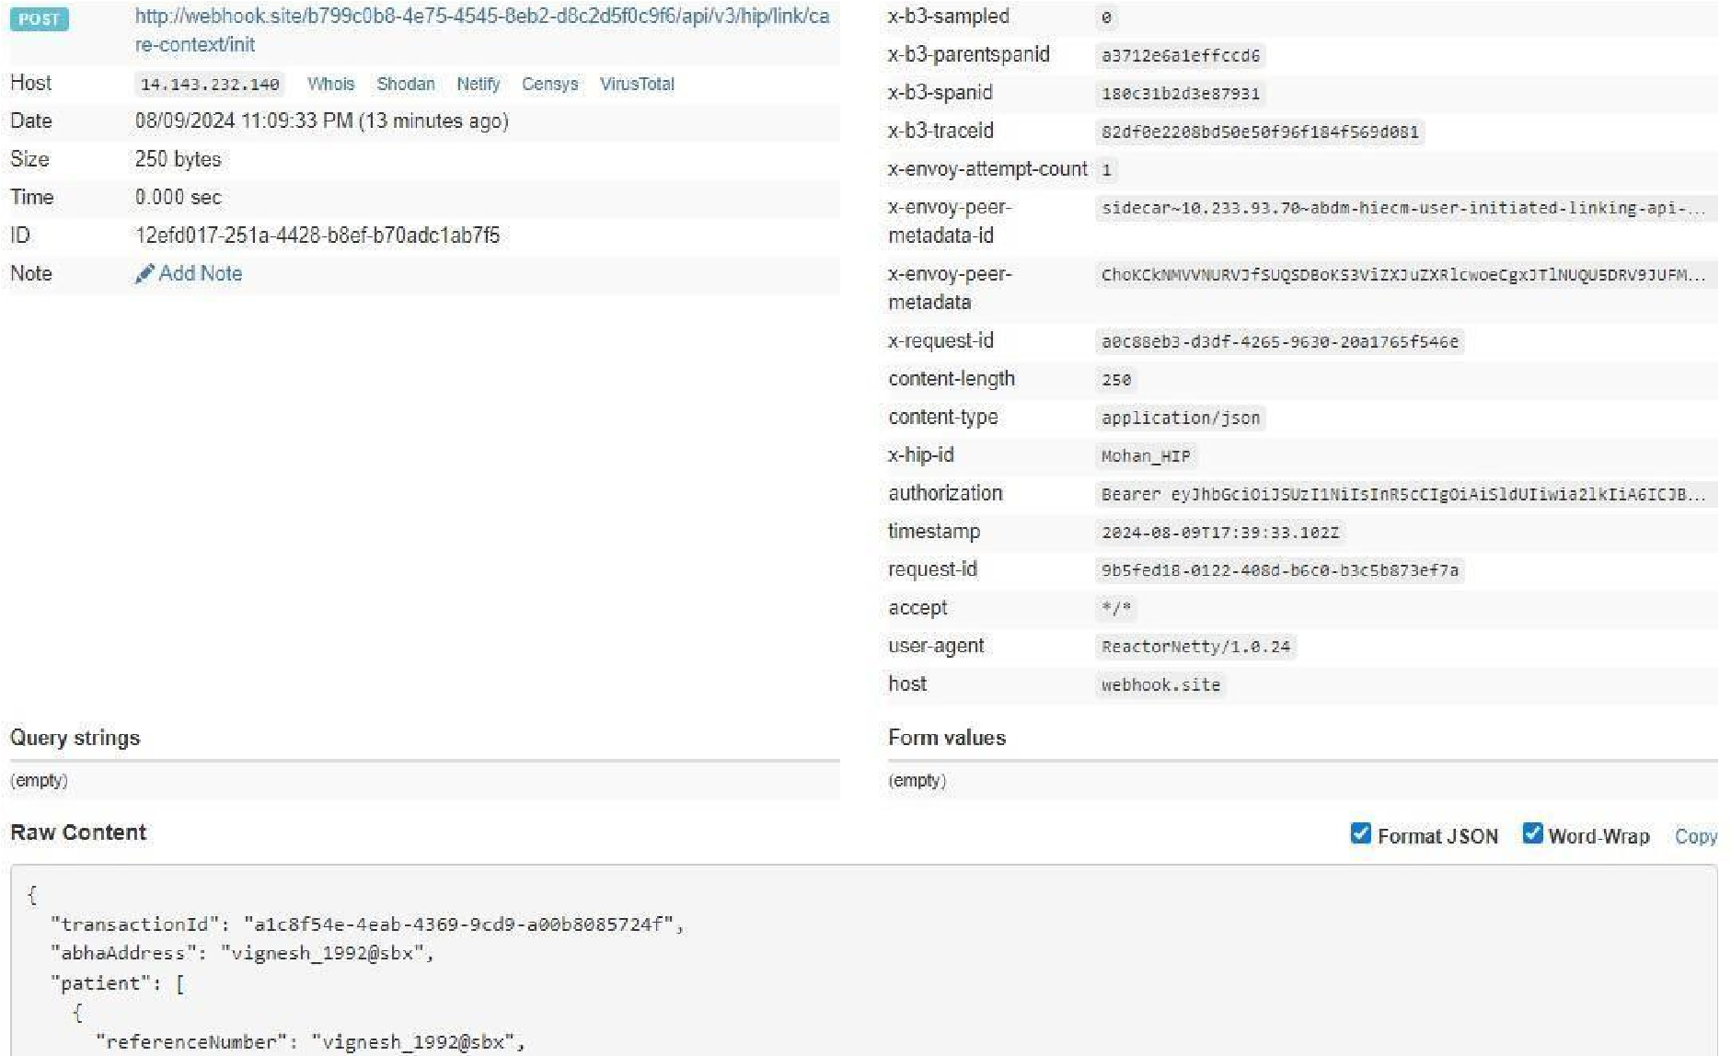
Error Response : (Already linked care context )
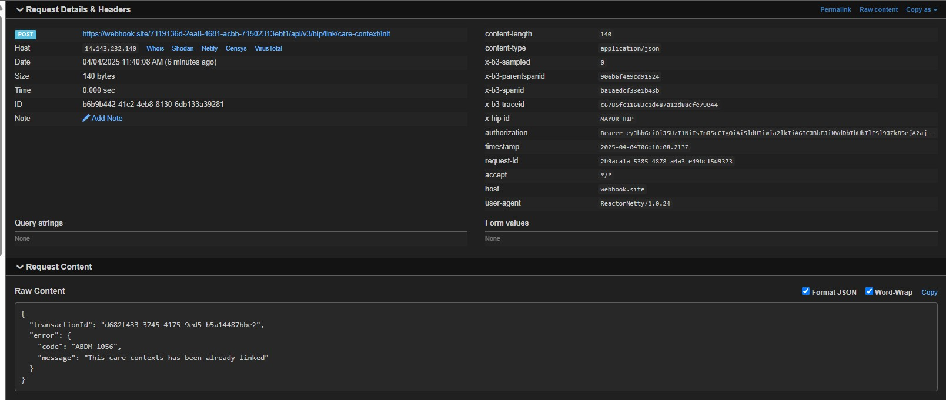

5.3.7 HMIS/LMIS response on health record link

This API will be invoked by the HMIS/LMIS to share the response of link init API
(referenceNumber will be generated by HIP and this will used in the confirm API)
URL: /api/hiecm/user-initiated-linking/v3/link/care-context/on-init
Request: POST
Header
Parameters:
Property  Name | Example Value | Required | Description
Authorization | eyJhbGciOiJSUzUxMiJ9. eyJzdWIiOiJ2YXNhb nRoYWt1bWFyLmtlc2F2YW5Ac2J4IiwiY2xpZW 50SWQiOiJzYngiLCJzeXN0ZW0iOiJBQkhBLUEi  LCJyZXF1ZXN0ZXJJZCI6IlBIUi1XRUIiLCJwaHJN | Yes | JWT Access token which was issued by ABDM session API after successful
 | b2JpbGUiOm51bGwsImV4cCI6MTY2NzI5ODE xNSwiaWF0IjoxNjY3MjkwOTE1LCJwaHJBZGRy ZXNzIjoidmFzYW50aGFrdW1hci5rZXNhdmFu  QHNieCIsInR4bklkIjoiYjEwMGM4ZDMtNTE1ZC0  0YWFiLTg1OWQtYzNlMTUwOTE3ZGY1In0 |  | validation of client id and secret
REQUEST-ID | 18235d89-cb13-479d-ad71-7a57d5f669a8 | Yes | Unique UUID for track the end to end request transaction
TIMESTAMP | 2022-10-06T10:10:00.587Z | Yes | Actual time when request was initiated, ISO Date time format represents date and time
X-CM-ID | sbx | Yes | Suffix of the consent manager to which the request was intended
Body Parameters:
Property Name | Example Value | Required | Description
transactionId | f901b782-bfdf-4224-9f8d-da2cadc20c0d | Yes | Transaction Id is required to identify the unique transaction for user initiated care context linking. This chains all the steps to link care contexts.Transaction Id will be returned after successful discovery request to HIP by the patient.
Link | {  "referenceNumber": "3336268d-89a34c84-  8674-aef42092d9fc",  "authenticationType": "MEDIATE",  "meta": {  "communicationMedium": "MOBILE",  "communicationHint": "OTP",  "communicationExpiry": "2023-  1230T12:01:55.324Z"  } | Yes | The details of the link using which the records has to be linked to the patient’s ABHA account. It will contain details like the referenceNumber,  authenticationType and the meta details  of the link
requestId | 2b835afb-0c97-4ce7-9dd9ef58ee98a326 | Yes | Request ID sent in init API call. This request ID will be used to match the flow of linking care contexts for a patient
Request Body:
Request Body:
{
"transactionId": "66446ece-396b-4f22-a1a6-756196fdffc9",
"link": {
"referenceNumber": "3336268d-89a3-4c84-8674-aef42092d9fc",
"authenticationType": " MEDIATE",
"meta": {
"communicationMedium": "MOBILE",
"communicationHint": "OTP",
"communicationExpiry": "2023-12-30T12:01:55.324Z"
}
},
"response": {
"requestId": "2b835afb-0c97-4ce7-9dd9-ef58ee98a326"
}
}
Response:
Response
Code : 202 Accepted

Error scenarios:

Scenarios | Headers/Body | Message
Verify when transaction id is invalid, null or blank | {  "transactionId": "",  "link": {  "referenceNumber": "Testing defe ct",  "authenticationType": " MEDIATE",  "meta": {  "communicationMedium": "MO  BILE",  "communicationHint": "OTP",  "communicationExpiry": "202306-  31T12:33:37.603Z"  }  },  "response": {  "requestId": "3a95d49d-c06b46cf-99b4-  695ec53316e2"  }  } | “Code”: " ABDM-9999: ",  “message”: "Invalid Transaction  Id ."

Verify message when communication  expiry date is invalid or null | "{  ""transactionId"": """",  ""link"": {  ""referenceNumber"": ""Testing defe ct"",  ""authenticationType"": ""DIRECT"",  ""meta"": {  ""communicationMedium"": ""MO  BILE"",  ""communicationHint"": ""OTP"",  ""communicationExpiry"": ""2023- 06-31T12: 33: 37.603Z""  }  },  ""response"": {  ""requestId"": ""3a95d49d-c06b46cf-99b4-  695ec53316e2""  }  } " | {  "code": "ABDM-9999: ",  "message": "Invalid communica tion expiry date."  }  400 Bad Request
Verify message when request ID is invalid or null | "{  ""transactionId"": """",  ""link"": {  ""referenceNumber"": ""Testing defe ct"",  ""authenticationType"": "" MEDIATE"",  ""meta"": {  ""communicationMedium"": ""MO  BILE"",  ""communicationHint"": ""OTP"",  ""communicationExpiry"": ""2023- 06-31T12: 33: 37.603Z""  }  },  ""response"": {  ""requestId"": ""3a95d49d-c06b46cf-99b4-  695ec53316e2""  } }" | {  "code": "ABDM-9999: ",  "message": "Invalid request ID"  }  400 Bad Request
When the  referenceNumber is null or empty. | {  "transactionId": "",  "link": {  "referenceNumber": ",  "authenticationType": " MEDIATE",  "meta": {  "communicationMedium": "MOBIL  E",  "communicationHint": "OTP",  "communicationExpiry": "2023- 06-31T12: 33: 37.603Z"  } | {  "code": "ABDM-9999: ",  "message": "Invalid reference number."  }

},
"response": {
"requestId”: "3a95d49d-c06b46cf-99b4-
695ec53316e2"
}
}

When the  authenticationTypeis null or empty. | {  "transactionId": "",  "link": {  "referenceNumber": “12345",  "authenticationType": "",  "meta": {  "communicationMedium": "MOBIL  E",  "communicationHint": "OTP",  "communicationExpiry": "2023-  06-31T12: 33: 37.603Z"  }  },  "response": {  "requestId”: "3a95d49d-c06b46cf-99b4-  695ec53316e2"  }  } | {  "code": "ABDM-9999: ", "message":  “Invalid authentication type”  }
When the  communicationMedi um is null or empty. | {  "transactionId": "3a95d49d-c06b46cf-99b4-  695ec53316e2",  "link": {  "referenceNumber": “12345",  "authenticationType": "",  "meta": {  "communicationMedium": "",  "communicationHint": "OTP",  "communicationExpiry": "2023- 06-31T12: 33: 37.603Z"  }  },  "response": {  "requestId”: "3a95d49d-c06b46cf-99b4-  695ec53316e2"  }  } | {  "code": "ABDM-9999: ",  "message": “Invalid communication medium”  }
When the  communicationHint is null or empty. | {  "transactionId": "3a95d49d-c06b46cf-99b4-  695ec53316e2",  "link": {  "referenceNumber": “12345",  "authenticationType": "",  "meta": {  "communicationMedium": "DIREC  T",  "communicationHint": "",  "communicationExpiry": "2023- 06-31T12: 33: 37.603Z"  }  },  "response": {  "requestId”: "3a95d49d-c06b46cf-99b4-  695ec53316e2"  }  } | {  "code": "ABDM-9999: ", "message":  “Invalid communication hint”  }

5.3.8 HIE-CM response on health record link

This is a callback API that will be invoked by the HIE-CM to share the response of the link oninit request from HIP
URL: {callback_url}/api/v3/hiu/patient/care-context/on-init Request: POST
Header Parameters:
Property Name | Example Value | Required | Description
Authorization | eyJhbGciOiJSUzUxMiJ9. eyJzdWIiOiJ2YXNhbnRoY Wt1bWFyLmtlc2F2YW5Ac  2J4IiwiY2xpZW50SWQiOi  JzYngiLCJzeXN0ZW0iOiJ  BQkhBLUEiLCJyZXF1ZXN0Z  XJJZCI6IlBIUi1XRUIiLCJwa  HJNb2JpbGUiOm51bGws  ImV4cCI6MTY2NzI5ODEx NSwiaWF0IjoxNjY3MjkwO TE1LCJwaHJBZGRyZXNzIjo idmFzYW50aGFrdW1hci5 rZXNhdmFuQHNieCIsInR 4bklkIjoiYjEwMGM4ZDMt NTE1ZC00YWFiLTg1OWQtY zNlMTUwOTE3ZGY1In0 | Yes | JWT Access token which was issued by ABDM session API after successful validation of client id and secret.
REQUEST-ID | 18235d89-cb13-479dad71-  7a57d5f669a8 | Yes | Unique UUID for track the end to end request transaction
TIMESTAMP | 2022-10-  06T10:10:00.587Z | Yes | Actual time when request was initiated, ISO Date time format represents date and time
X-HIU-ID | IN2810014366 | Yes | Identifier of the health information user to which the request was intended
Body Parameters:
Property Name | Example Value | Required | Description
transactionId | f901b782-bfdf-4224-9f8d-  da2cadc20c0d | Yes | Transaction Id is required to identify the unique transaction for user initiated care context linking. This chains all the steps to link care contexts.Transaction Id will be returned after successful discovery request to HIP by the patient.
Link | {  "referenceNumber": "4336268d-89a34c84-  8674-aef42092d9fc",  "authenticationType": " MEDIATE",  "meta": {  "communicationMedium": "MOBILE",  "communicationHint": "OTP",  "communicationExpiry": "2023-  1230T12:01:55.324Z"  } } | No | The details of the link using which the records have to be linked to the patient’s ABHA account. It will contain details like the referenceNumber,  authenticationType and the meta details of  the link
error | "error": {  "code": 1000,  "message": "string"  } | No | The error code and message if any occurred.
requestId | 2b835afb-0c97-4ce7-9dd9ef58ee98a326 | Yes | Request ID sent in init API call. This request ID will be used to match the flow of linking care contexts for a patient

Request Body:
Request Body:
{
"transactionId": "5b39f73e-b19a-421a-ab43-c97cbd903041",
"link": {
"referenceNumber": "4336268d-89a3-4c84-8674-aef42092d9fc",
"authenticationType": " MEDIATE",
"meta": {
"communicationMedium": "MOBILE",
"communicationHint": "OTP",
"communicationExpiry": "2023-12-30T12:01:55.324Z"
}
},
"response": {
"requestId": "14a298b4-cf4a-497b-b4c1-72b50295fb91"
}
}

Response:

Response
Code : 202 Accepted

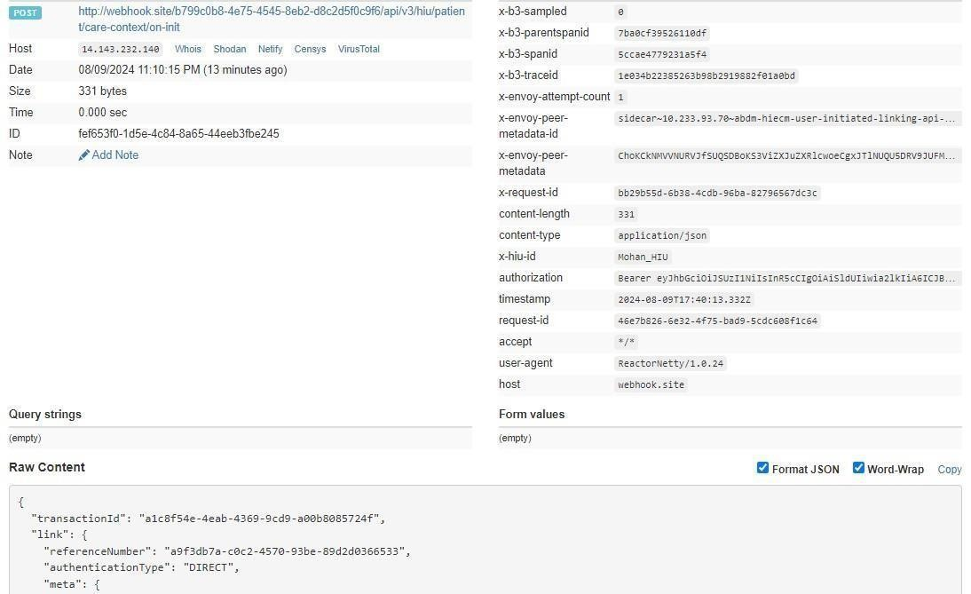

5.3.9 Patient health record confirm

This API will be invoked by the patient to confirm his/her health records.
URL: /api/hiecm/user-initiated-linking/v3/link/care-context/confirm
Request: POST Header Parameters:
Property  Name | Example Value | Required | Description
Authorization | eyJhbGciOiJSUzUxMiJ9. eyJzdWIiOiJ2YXN hbnRoYWt1bWFyLmtlc2F2YW5Ac2J4IiwiY 2xpZW50SWQiOiJzYngiLCJzeXN0ZW0iOiJ  BQkhBLUEiLCJyZXF1ZXN0ZXJJZCI6IlBIUi1XR  UIiLCJwaHJNb2JpbGUiOm51bGwsImV4c  CI6MTY2NzI5ODExNSwiaWF0IjoxNjY3Mjkw OTE1LCJwaHJBZGRyZXNzIjoidmFzYW50aG FrdW1hci5rZXNhdmFuQHNieCIsInR4bklkIj oiYjEwMGM4ZDMtNTE1ZC00YWFiLTg1OWQ tYzNlMTUwOTE3ZGY1In0 | Yes | JWT Access token which was issued by ABDM session API after successful validation of client id and secret
REQUEST-ID | 18235d89-cb13-479d-ad71-  7a57d5f669a8 | Yes | Unique UUID for track the end to end request transaction
TIMESTAMP | 2022-10-06T10:10:00.587Z | Yes | Actual time when request was initiated, ISO Date time format represents date and time
X-AUTH-TOKEN | eyJhbGciOiJSUzUxMiJ9.eyJzdWIiOiJ2 YXNhbnRoYWt1bWFyLmtlc2F2 |  | JWT Authentication token which was issued by ABDM after successful validation of username and password
X-HIU-ID | HIU_ID | Yes | Identifier of the health information user by which the request was  initiated
X-CM-ID | sbx | Yes | Suffix of the consent manager to which the request was intended

Body Parameters:
Property Name | Example Value | Required | Description
linkRefNumber | “4336268d-89a3-4c84-  8674aef42092d9fc” | Yes | Link reference number used while initiating the linking of health records of the patient
token | “123456” | Yes | OTP generated during init process to confirm the linking
Request Body:
Request Body
{
"token": 123456,
"linkRefNumber": "4336268d-89a3-4c84-8674-aef42092d9fc" }
Response:
Response
Code : 202 Accepted

Error scenarios:

Scenarios | Headers/Body | Message
To verify when  Request ID is Blank, null or empty in header | [  {  "key": "REQUEST-ID",  "value": "",  "type": "text"  } ] | Access Denied  Code : 403  Forbidden
To verify when invalid RequestID is pass in header | [  {  "key": "REQUEST-ID",  "value": "{{$guid}}zxzzxs",  "type": "text"  }  ] | {  "code": "ABDM-1030: ", "message":  "Invalid  request ID"  }  Code: 400Bad Request

When  Timestamp is Blank, null or empty in header. | [  {  "key": "TIMESTAMP", "value": "",  "type": "text"  } ] | Access Denied  Code : 403 Forbidden
When invalid Timestamp is pass in header | [  {  "key": "TIMESTAMP",  "value": "{{$isoTimestamp}}jhgftytgtyu",  "type": "text"  } ] | {  "code": "ABDM-1016: ",  "message": "Invalid Timestamp"  }  Code - 400Bad Request
When X- HIU-ID is Blank, null or empty in header. | [  {  "key": "X-HIU-ID",  "value": "",  "type": "text"  }  ] | Access Denied  Code : 403 Forbidden
When X-CM-  ID is Invalid, Blank, null or empty in header. | [  {  "key": "X-CM-ID",  "value": "sbxdvdfvdf",  "type": "text"  }  ] | Access Denied  Code : 403 Forbidden
When  XAuthTOKEN is Invalid in header. | [  {  "key": "X-LINK-TOKEN",  "value": "hghhjjkhjkbkjbjkbkjbnkjbk",  "type": "text"  }  ] | {  ""code"": ""ABDM-1066: "",  ""message"": ""Invalid  JWT token""  }  Code - 400Bad Request"
Verify  message when invalid token is passed | {  "token": 7897654,  "linkRefNumber": "Testing defect"  } | {  "code": "ABDM-9999: ", "message":  Invalid link reference number."  }
Verify  message when the X- HIU-ID is different from the hiu that initiated link request. |  | {  "code": "ABDM-1040: ",  "message": “Invalid HIU ID."  }

5.3.10 HIE-CM callback for health record confirmation

This API will be invoked by the HIE-CM to confirm patient health records to HIP
URL: {callback_url}/api/v3/hip/link/care-context/confirm
Request: POST Header Parameters:
Property Name | Example Value | Required | Description
REQUEST-ID | 18235d89-cb13-479d-ad71-  7a57d5f669a8 | Yes | Unique UUID for tracking the endto-end request transaction
TIMESTAMP | 2022-10-06T10:10:00.587Z | Yes | Actual time when request was initiated, ISO Date time format represents date and time
X-HIU-ID | IN2810014366 | Yes | Identifier of the health information provider to which the request was intended
Body Parameters:
Property Name | Example Value | Required | Description
linkRefNumber | “4336268d-89a3-4c84-8674aef42092d9fc” | Yes | Link reference number used while initiating the linking of health records of the patient
Token | “123456” | Yes | OTP generated during init process to confirm the linking
Request Body:
Request Body:
{
"confirmation": {
"token": "123456",
"linkRefNumber": "4336268d-89a3-4c84-8674-aef42092d9fc"
}
}
Response:
Response
Code : 202 Accepted

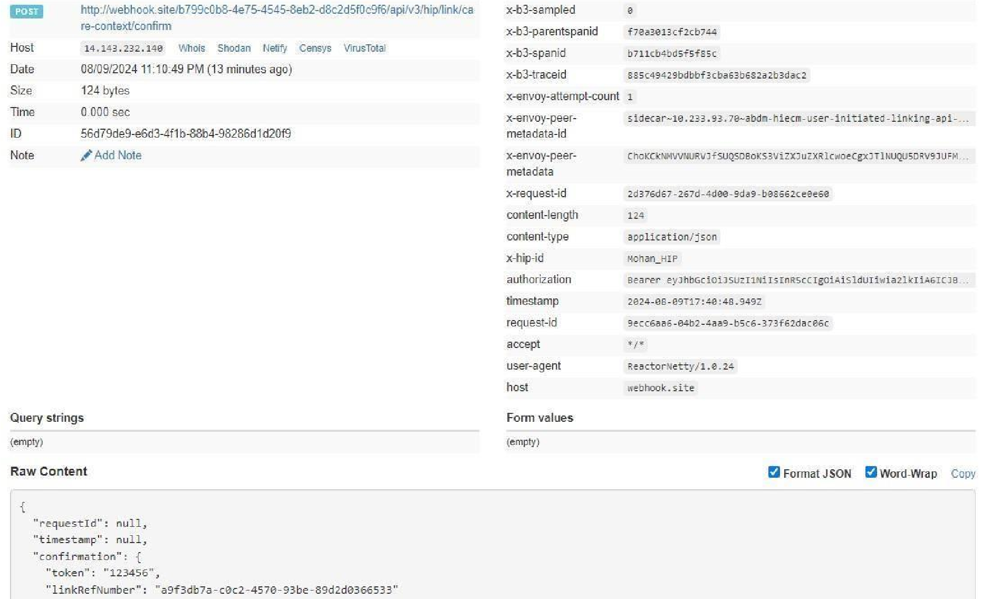

5.3.11 HMIS/LMIS response on health record confirm
This API will be invoked by the HIP to share the response of link confirmation API
URL: /api/hiecm/user-initiated-linking/v3/link/care-context/on-confirm Request:
POST
Header Parameters:
Property Name | Example Value | Required | Description
Authorization | eyJhbGciOiJSUzUxMiJ9. eyJzdWIiOiJ2YXNhb nRoYWt1bWFyLmtlc2F2YW5Ac2J4IiwiY2xpZW 50SWQiOiJzYngiLCJzeXN0ZW0iOiJBQkhBLUEi LCJyZXF1ZXN0ZXJJZCI6IlBIUi1XRUIiLCJwaHJN b2JpbGUiOm51bGwsImV4cCI6MTY2NzI5ODE xNSwiaWF0IjoxNjY3MjkwOTE1LCJwaHJBZGRy ZXNzIjoidmFzYW50aGFrdW1hci5rZXNhdmFu  QHNieCIsInR4bklkIjoiYjEwMGM4ZDMtNTE1ZC0  0YWFiLTg1OWQtYzNlMTUwOTE3ZGY1In0 | Yes | JWT Access token which was issued by ABDM session API after successful validation of client id and secret
REQUEST-ID | 18235d89-cb13-479d-ad71-7a57d5f669a8 | Yes | Unique UUID for track the end to end request transaction
TIMESTAMP | 2022-10-06T10:10:00.587Z | Yes | Actual time when request was initiated, ISO Date time format represents date and time
X-CM-ID | sbx | Yes | Suffix of the consent manager to which the request was intended
Body Parameters:
Property Name | Example Value | Required | Description
patient | - | Yes | A list of records of the patient that were found as a result of the identifiers that the patient had provided.
referenceNumber | “4336268d-89a34c84-  8674aef42092d9fc” | Yes | Link reference number used while initiating the linking of health records of the patient
Display | Display Text | No | The display text for patient reference
careContexts | - | Yes | List of care contexts linked at the HIP end for the identified patient.
hiType | PRESCRIPTION | Yes | HiType of the patient details
Count | 1 | Yes | The count of care contexts that are found for the patient in scope
requestId | f207e461-1994-  42749b86554384f170ab | Yes | Request ID sent in init API call. This request ID will be used to match the flow of linking care contexts for a patient
Request Body:
Request Body:
{
"patient": [
{
"referenceNumber": "4336268d-89a3-4c84-8674-aef42092d9fc", "display": "abcdefgdisplay", "careContexts": [
{
"referenceNumber": "1234",
"display": "1234-display"
}
],
"hiType": "PRESCRIPTION",
"count": 1
}
],
"response": {
"requestId": "f207e461-1994-4274-9b86-554384f170ab"
} }
Response:
Response
Code : 202 Accepted

Error scenarios:

Scenario s | Request Body | Response

To verify when  Request ID is Blank, null or empty in header | [  {  "key": "REQUEST-ID",  "value": "",  "type": "text"  } ] | Access Denied  Code : 403 Forbidden
To verify when  invalid Request-ID is pass in header | [  {  "key": "REQUEST-ID",  "value": "{{$guid}}zxzzxs", "type": "text"  }] | {  "code": "ABDM-1030: ",  "message": "Invalid request ID"  }  Code: 400Bad Request

When X- HIP-ID is Blank, null or empty in header. | [  {  "key": "X-HIP-ID",  "value": "",  "type": "text"  } ] | Access Denied  Code : 403 Forbidden
When X- CM-ID  is  Invalid,  Blank, null or empty in header. | [  {  "key": "X-CM-ID",  "value": "sbxdvdfvdf",  "type": "text"  } ] | Access Denied  Code : 403 Forbidden
Verify  message when request id is passed | {  "patient": [  {  "referenceNumber": "Testing defe ct",  "display": "bg",  "careContexts": [  {  "referenceNumber": "1234",  "display": "12"  }  ],  "hiType": "PRESCRIPTION",  "count": 1  }  ],  "response": {}  } | {  "code": "ABDM-1015",  "message": "Invalid Response"  }
Verify  message when count is incorrect | {  "patient": [  {  "referenceNumber": "Testing defe ct",  "display": "bg",  "careContexts": [  {  "referenceNumber": "1234",  "display": "12"  }  ],  "hiType": "PRESCRIPTION",  "count": 1  }  ],  "response": {  "requestId": "f9d77c6b-e918-438da19f-  835f356c118b"  } | "{  ""code"": ""ABDM-9999: "",  ""message"": ""Invalid Care  Contexts count, must range between 1 to  20""  } "

5.3.12 HIE-CM response on health record on-confirm
This is callback API will be invoked by the HIE-CM to share the response of on-confirm API from HIP.
URL: {callback_url}/api/v3/hiu/patient/care-context/on-confirm
Request: POST

Header Parameters:
Property Name | Example Value | Required | Description
REQUEST-ID | 18235d89-cb13-479d-ad71-  7a57d5f669a8 | Yes | Unique UUID for tracking the endto-end request transaction
TIMESTAMP | 2022-10-06T10:10:00.587Z | Yes | The actual time when the request was initiated, ISO Date time format represents the date and time
X-HIU-ID | IN2810014366 | Yes | Identifier of the health information provider to which the request was intended
Body Parameters:
Property Name |  | Example Value | Required | Description
patient | - |  | Yes | A list of records of the patient that were found as a result of the identifiers that the patient had provided.
referenceNumber | “4336268d-89a34c84-  8674aef42092d9fc” |  | Yes | Link reference number used while initiating the linking of health records of the patient
careContexts | - |  | Yes | List of care contexts linked at the HIP end for the identified patient.
hiType | PRESCRIPTION |  | Yes | HiType of the patient details
Count | 1 |  | Yes | The count of care contexts that are found for the patient in scope
requestId | f207e461-1994-  42749b86554384f170ab |  | Yes | Request ID sent in the init API call. This request ID will be used to match the flow of linking care contexts for a patient
Request Body:

Request Body
{
"patient": [
{
"referenceNumber": "4336268d-89a3-4c84-8674-aef42092d9fc", "display": "abcdefgdisplay",
"careContexts": [
{
"referenceNumber": "1234",
"display": "1234-display"
}
],
"hiType": "PRESCRIPTION",
"count": 1
}
],
"response": {
"requestId": "f207e461-1994-4274-9b86-554384f170ab"
}
}

Response:

Response
Code : 202 Accepted

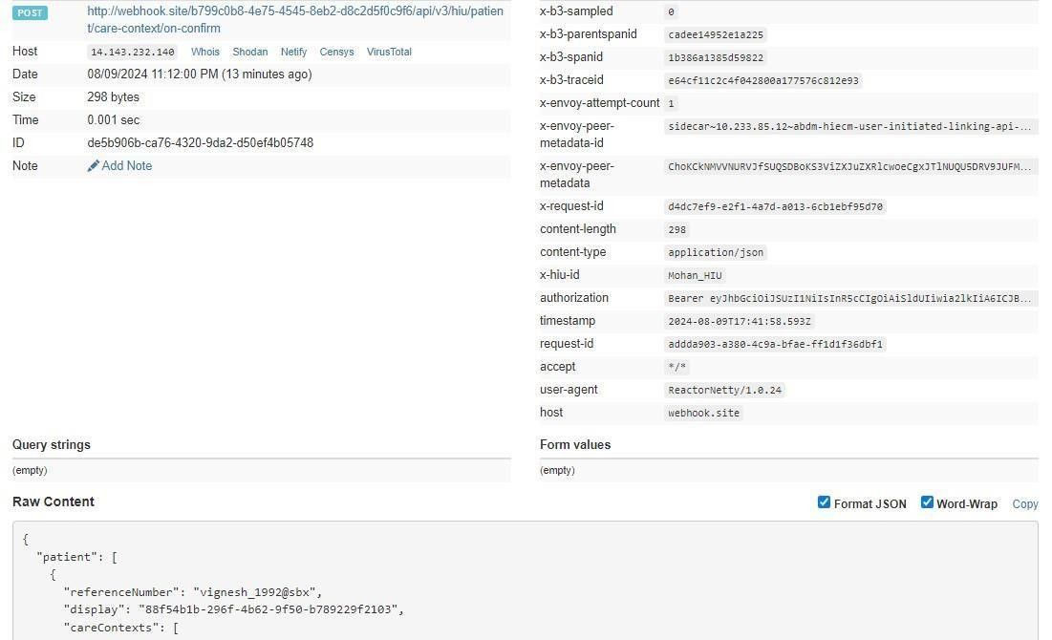

6.Data Flow

6.1 Overview
The process of Data flow starts once the HIECM has generated Consent artefact (Consent artefact is generated only if the status of Consent request is “Granted”) and same is notified to HIP and HIU. HIU sends pushback URL to HIP via HIECM. HIP now bundles the care context or Health data of the patient as per FHIR standards and share the data via pushback data URL. HIECM is notified the status of the data shared both by HIU and HIP.

6.2 Sequence Diagram

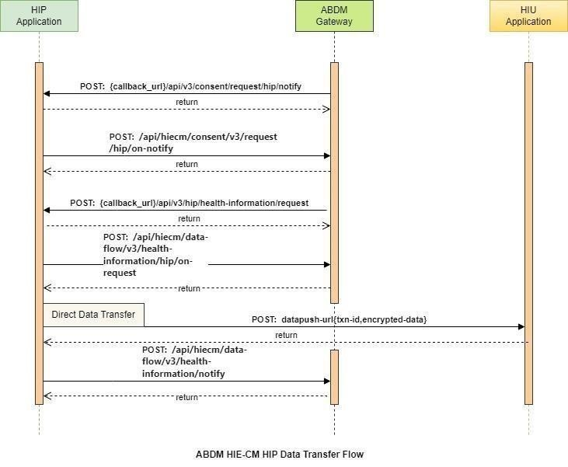

6.3 List of APIs

6.3.1 Callback API to HIP when a consent request is APPROVED/REVOKED

This API is a callback to HIP when a consent request is approved/revoked.
URL: {callbackURL}/api/v3/consent/request/hip/notify
Request: POST

Header Parameters:
Property Name | Example Value | Required | Description
REQUEST-ID | 18235d89-cb13-479d-ad71-  7a57d5f669a8 | Yes | Unique UUID for track the end to end request transaction
TIMESTAMP | 2022-10-06T10:10:00.587Z | Yes | Actual time when request was initiated, ISO Date time format represents date and time
X-HIP-ID | eyJhbGciOiJSUzUxMiJ9.eyJzdWIiOiIx  ODQ0MzgxMDgwNjQ0MEBhYmRt | Yes | Identifier to the health information provider.
Body parameters:
Property Name | Example Value |  | Required | Description
Status | GRANTED | Yes |  | The status of the consent artefact
consentId | 3fa85f64-5717-4562b3fc-  2c963f66afa6 | Yes |  | The consent artefact  id
createdAt | 2024-05-  01T05:10:20.123Z | Yes |  | The date when consent artefact was created.
patient | abc@abdm | Yes |  | A unique and valid ABHA address suffix with @abdm for live and @sbx for  Sandbox
Hip | ABDM_HIP | No |  | Health information provider ID
purpose – text | Care Management | Yes |  | Purpose text of consent request
Purpose-code | CAREMGT | Yes |  | Purpose code of consent request
Purpose-refUri | www.test.com | Yes |  | Purpose refUri of consent request
patientReference | batman@tmh | No |  | Patient reference Id
careContextReference | Episode11 | No |  | Care context reference
Hiu | Sub_HIU | Yes |  | Health information user Id
Requester-name | Smith | Yes |  | Name of the requester

Requester-identifiertype | REGN01 | Yes | Requester identifier type
Requester-identifiervalue | MH1001 | Yes | Requester identifier value
Requester-identifiersystem | https://www.mciindia. org | Yes | Requester identifier system
hiTypes | ["OPCONSULTATION",  "WELLNESSRECORD"] | Yes | Type of document
PermissionaccessMode | VIEW | Yes | Access mode of consent
PermissiondateRange | "from": "2023-  0509T08:58:09.738Z",  "to": "2023-  0510T08:58:09.738Z" | Yes | Data range of permission required
PermissiondateEraseAt | 2023-05-  25T08:58:09.738Z | Yes | Date of erase data
Permissionfrequency-value | 0 | Yes | Frequency value for consent
Permissionfrequencyrepeats | 0 | Yes | Frequency repeats for consent
Permissionfrequency-unit | HOUR | Yes | Frequency unit for consent
Signature | e8nY601CYDsC0FKoDj Sp+7GeQ2s2R8oZncLC z5ce+pEuDOr5bZV0aa HjwJg4b9S9V+twjt4hb ojx3fl7egrt8+0c+lfPTi5 /bBUAQXCABTfFmtFU7 jn65HlTt8kgkiONx26ZB hJ0wX3xjYI72PPtzYIiT5 Q08YtDoILA62KceioV7l wuKssw7wC4ECbBAvR uXT121TmtrPhf+0myJA TSnaajS06S6OthrKfZLN  TUFf3pFiJzqouSTrjNblO  X6DT2+JuO3rom1Szz/0  3c0HQG+wWASv+PO3  J6uRs0UI4JvKmM/4tP  +Z+/HPKM15K5U5K+4p qf6czKrbIDpkT/kP8bG g== | Yes | Signature of signed consent artefact details.
grantAcknowledgeme  nt | False | Yes | The Boolean flag to denote if HIP acknowledged the callback.

Request Body:
Request Body:

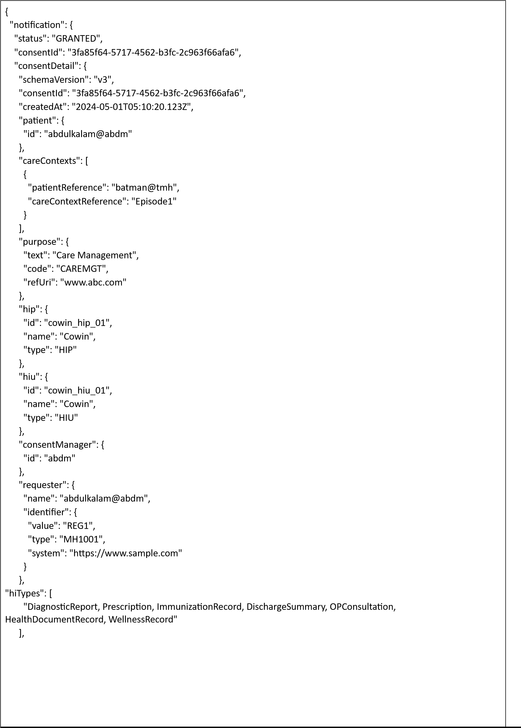
"permission": {
"accessMode": "VIEW",
"dateRange": {
"from": "2021-09-28T12:30:08.573565Z",
"to": "2021-09-28T12:30:08.573565Z"
},
"dataEraseAt": "2021-09-28T12:30:08.573565Z",
"frequency": {
"unit": "HOUR",
"value": 1,
"repeats": 0
}
}
},
"signature":
"e8nY601CYDsC0FKoDjSp+7GeQ2s2R8oZncLCz5ce+pEuDOr5bZV0aaHjwJg4b9S9V+twjt4hbojx3fl7e grt8+0c+lfPTi5/bBUAQXCABTfFmtFU7jn65HlTt8kgkiONx26ZBhJ0wX3xjYI72PPtzYIiT5Q08YtDoILA62Kce ioV7lwuKssw7wC4ECbBAvRuXT121TmtrPhf+0myJATSnaajS06S6OthrKfZLNTUFf3pFiJzqouSTrjNblOX6D
T2+JuO3rom1Szz/03c0HQG+wWASv+PO3J6uRs0UI4JvKmM/4tP+Z+/HPKM15K5U5K+4pqf6czKrbIDpk T/kP8bGg==", "grantAcknowledgement": false
} }
Response Body:
Response
Status: 202 Accepted

6.3.2 HIP to respond back to consent HIP notify

This API will be invoked by HIP to respond back to the callback API
URL: /api/hiecm/consent/v3/request/hip/on-notify
Request: POST
Header Parameters:
Property Name | Example Value | Required | Description
REQUEST-ID | 18235d89-cb13-479d-ad71-  7a57d5f669a8 | Yes | Unique UUID for track the end to end request transaction
TIMESTAMP | 2022-10-06T10:10:00.587Z | Yes | Actual time when request was initiated, ISO Date time format represents date and time
X-CM-ID | sbx | Yes | Suffix of the consent manager to which the request was intended
Body parameters:
Property Name | Example Value |  | Required | Description
Status | OK | Yes |  | The status of the consent notify.
consentId | 3fa85f64-5717-4562b3fc-  2c963f66afa6 | Yes |  | The consent artefact  id
Error | "error": {  "code": "ABDM-1001", "message": "unable to connect database"  } | No |  | The error code and message if any happened.
requestId | 3fa85f64-5717-4562b3fc-  2c963f66afa6 | Yes |  | The request id from the /consent/hip/notify
Request Body:
Request Body:
{
"acknowledgement": {
"status": "OK",
"consentId": "e3c74829-3f82-4f94-959e-e10f57bcd57b"
},
"error": {
"code": "ABDM-1001",
"message": "unable to connect database"
},
"response": {
"requestId": "6f0b4665-a915-4c92-aa36-65afb4a2cd71"
} }
Response Body:
Response
Status: 202 Accepted

6.3.3 Data Flow - Health information request – Callback to HIP

This isa callback API triggered by HIE-CM to notify HIP about the health information request.
URL: {callback_URL}/api/v3/hip/health-information/request Request: POST Header Parameters:
Property Name | Example Value |  | Required | Description
Authorization | eyJhbGciOiJSUzUxMiJ9. eyJzdWIiOiJ2YXNhbnRoY Wt1bWFyLmtlc2F2YW5Ac  2J4IiwiY2xpZW50SWQiOi JzYngiLCJzeXN0ZW0iOiJ  BQkhBLUEiLCJyZXF1ZXN0Z  XJJZCI6IlBIUi1XRUIiLCJwa  HJNb2JpbGUiOm51bGws  ImV4cCI6MTY2NzI5ODEx NSwiaWF0IjoxNjY3MjkwO TE1LCJwaHJBZGRyZXNzIjo idmFzYW50aGFrdW1hci5 rZXNhdmFuQHNieCIsInR 4bklkIjoiYjEwMGM4ZDMt NTE1ZC00YWFiLTg1OWQtY zNlMTUwOTE3ZGY1In0 | Yes |  | JWT Access token which was issued by ABDM session API after successful validation of client id and secret.
REQUEST-ID | 18235d89-cb13-479dad71-  7a57d5f669a8 | Yes |  | Unique UUID for tracking the end-to-end request transaction
TIMESTAMP | 2022-10-  06T10:10:00.587Z | Yes |  | The actual time when the request was initiated, ISO Date time format represents the date and time
X-HIP-ID | IN2810014366 | Yes |  | Identifier to the health information provider.
Body Parameters:
Property  Name | Example Value | Required | Description
Consent ID | 18235d89-cb13-479d-ad71-7a57d5f669a8 | Yes | Valid consent ID, which HIU must obtain to request patient data from a HIP

DateRange | [  {  "from": "1924-07-09T12:05:57.151Z",  "to": "2024-07-17T12:05:57.151Z"  } ] | Yes | Date Range against which the consent granted will be validated.
DataPushUrl | https://webhook.site/2cfcc184-5d29-  4e2c974d3e56cbaa5cc1/v3/data/push | Yes | This is the URL provided by HIU to which HIP has to push the requested health information record
cryptoAlg | “ECDH” |  | ECDH is a key sharing algorithm,  most commonly  used to send encrypted messages.  ECDH works by multiplying your private key by another's public key to get a shared secret, then using that shared secret to perform symmetric encryption
curve | “curve25519” | Yes | Key exchanges authentication
expiry | 2124-12-09T00:00:00.000Z | Yes | Actual time by when dataPushUrl is available
parameters | “Ephemeral public key” | Yes | Encryption and decryption key
keyValue | BFN7KTdOT0jIAExG2A8Jg+01w  MPWxptiGqwHRVvtiVEsUq2FR7P2  UdqZxJyPJSeR6muai21iQhasNxnhh8I5M+g=" | Yes | key agreement protocol that allows two parties, each
 |  |  | having an ellipticcurve public– private key pair, to establish a shared secret over an insecure channel
Request Body:
Request Body
{
"hiRequest": {
"consent": {
"id": "d6a83f24-6c96-421e-b8b8-844e5344ef69"
},
"dateRange": {
"from": "1924-07-09T12:05:57.151Z",
"to": "2024-07-17T12:05:57.151Z"
},
"dataPushUrl": "https://webhook.site/2cfcc184-5d29-4e2c-974d3e56cbaa5cc1/v3/data/push",
"keyMaterial": {
"cryptoAlg": "ECDH",
"curve": "Curve25519",
"dhPublicKey": {
"expiry": "2124-12-09T00:00:00.000Z",
"parameters": "Curve25519/32byte random key",
"keyValue":
"BCpsBW37KgfLyjxJK0zHHG26hDjxzK368DEO4PapzFhQM0cghZziKuvJh5/anTnHitVHKMn0Owr1HvcH1f m0DpA="
},
"nonce": "0ka0stPfqmXWhX+ODC/iOFMO0PXFdRjBdcEGbv55qqc="
}
} }

Response:

Response
Code : 202 Accepted

6.3.4 HIP acknowledgement to the health information request

This API will be invoked by HIP to acknowledge the health information request by HIU.
URL: /api/hiecm/data-flow/v3/health-information/hip/on-request Request: POST Header Parameters:
Property Name | Example Value |  | Required | Description
Authorization | eyJhbGciOiJSUzUxMiJ9. eyJzdWIiOiJ2YXNhbnRoY Wt1bWFyLmtlc2F2YW5Ac  2J4IiwiY2xpZW50SWQiOi JzYngiLCJzeXN0ZW0iOiJ  BQkhBLUEiLCJyZXF1ZXN0Z  XJJZCI6IlBIUi1XRUIiLCJwa  HJNb2JpbGUiOm51bGws  ImV4cCI6MTY2NzI5ODEx NSwiaWF0IjoxNjY3MjkwO TE1LCJwaHJBZGRyZXNzIjo idmFzYW50aGFrdW1hci5 rZXNhdmFuQHNieCIsInR 4bklkIjoiYjEwMGM4ZDMt NTE1ZC00YWFiLTg1OWQtY zNlMTUwOTE3ZGY1In0 | Yes |  | JWT Access token which was issued by ABDM session API after successful validation of client id and secret.
REQUEST-ID | 18235d89-cb13-479dad71-  7a57d5f669a8 | Yes |  | Unique UUID for tracking the end-toend request transaction
TIMESTAMP | 2022-10-  06T10:10:00.587Z | Yes |  | The actual time when the request was initiated, ISO Date time format represents the date and time
X-CM-ID | IN2810014366 | Yes |  | Suffix of the consent manager to which the request was intended.
Body Parameters:
Property Name | Example Value |  | Required | Description
transactionId | 18235d89-cb13-479dad71-  7a57d5f669a8 | No |  | Unique transaction id to track the health information request
sessionStatus | ACKNOWLEDGED | No |  | Status of the request
Error |  | No |  | Error code and message if any occurred
requestId | 18235d89-cb13-479dad71-  7a57d5f669a8 | Yes |  | Unique id to track end to end transaction
Request Body:
Request Body
{
"hiRequest": {
"transactionId": "18235d89-cb13-479d-ad71-7a57d5f669a8", "sessionStatus": "ACKNOWLEDGED"
},
"response": {
"requestId": "18235d89-cb13-479d-ad71-7a57d5f669a8 “
}
}
Request Body : Error scenario
Request Body
{
"error": {
"code": ABDM-1001,
"message": " unable to connect database"
},
"response": {
"requestId": "18235d89-cb13-479d-ad71-7a57d5f669a8 "
} }

Response:

Response
Code : 202 Accepted

6.3.5 HIP calling data push URL
This API will be invoked by HIP to push the data to HIU.
URL: /api-hiu/data/notification
Request: POST
Body Parameters:
Property Name |  | Example Value |  | Required | Description
pageNumber | 1 |  | Yes |  | The page number
pageCount | 2 |  | Yes |  | The total page count

transactionId | 18235d89-cb13-479dad71-  7a57d5f669a8 | Yes | The transaction id that is generated when health information request initiated.
entries | "entries": [  {"content": "{{content}}",  "media":  "application/fhir+json", | Yes | List of encrypted content details.
"checksum":
"{{checksum}}",

"careContextReference":
"{{care Context
Reference}}"
}
]

keyMaterial | "keyMaterial": {  "cryptoAlg": "ECDH",  "curve":  "Curve25519",  "dhPublicKey": {  "expiry": "{{expiry date}}",  "parameters":  "Curve25519/32byte random key",  "keyValue": "{{Key value}}"  },  "nonce": "{{nonce}}"  } | Yes | Encryption/Decryption key details
Request Body:

Request Body

{

"pageNumber": 0,

"pageCount": 1,

"transactionId": "{{transactionId}}",

"entries": [

"content": "{{content}}",
{

"media": "application/fhir+json",

"checksum": "{{checksum}}",

"careContextReference": "{{care Context Reference}}"

}
],
"keyMaterial": {
"cryptoAlg": "ECDH",
"curve": "Curve25519",
"dhPublicKey": {
"expiry": "{{expiry date}}",
"parameters": "Curve25519/32byte random key",
"keyValue": "{{Key value}}"
},
"nonce": "{{nonce}}"
}
}

Response:

Response
Code : 202 Accepted

6.3.6 Health Information notify API

This API will be called by HIU and HIP to notify the CM about the status of the data transfer.

HIP on the transfer of data would send sessionStatus - one of [TRANSFERRED, FAILED].
HIP would also send hiStatus for each careContextReference - on of [DELIVERED, ERRORED]

HIU on receipt of data would send sessionStatus - one of [RECEIVED, FAILED]. For example, ERRORED when data was not sent or if invalid data was sent. HIU would also send hiStatus for each careContextReference - one of [OK, ERRORED]. URL: /api/hiecm/data-flow/v3/health-information/notify
Request: POST
Header Parameters:
Property Name | Example Value |  | Required | Description
Authorization | eyJhbGciOiJSUzUxMiJ9. eyJzdWIiOiJ2YXNhbnRoY Wt1bWFyLmtlc2F2YW5Ac  2J4IiwiY2xpZW50SWQiOi  JzYngiLCJzeXN0ZW0iOiJ  BQkhBLUEiLCJyZXF1ZXN0Z  XJJZCI6IlBIUi1XRUIiLCJwa HJNb2JpbGUiOm51bGws  ImV4cCI6MTY2NzI5ODEx NSwiaWF0IjoxNjY3MjkwO TE1LCJwaHJBZGRyZXNzIjo idmFzYW50aGFrdW1hci5 rZXNhdmFuQHNieCIsInR 4bklkIjoiYjEwMGM4ZDMt NTE1ZC00YWFiLTg1OWQtY zNlMTUwOTE3ZGY1In0 | Yes |  | JWT Access token which was issued by ABDM session API after successful validation of client id and secret.
REQUEST-ID | 18235d89-cb13-479dad71-  7a57d5f669a8 | Yes |  | Unique UUID for tracking the end-toend request transaction
TIMESTAMP | 2022-10-  06T10:10:00.587Z | Yes |  | The actual time when the request was initiated, ISO Date time format represents the date and time
X-CM-ID | IN2810014366 | Yes |  | Suffix of the consent manager to which the request was intended.
Body Parameters:
Property Name | Example Value | Required | Description
consentId | 97c3668e-49e3-4121b2d3-  1ca6d949cd8a | Yes | The consent artefact  id
transactionId | e3472dad-86c5-  42df9afdd7c13df2a564 | Yes | The transaction id that is generated when health information request initiated.
doneAt | 2023-05-  24T10:51:08.374Z | Yes | UTC date when the data was transferred/received.
notifier | "notifier": { | Yes | Identifier to denote  either  HIP or HIU is calling this  API
"type": "HIP",
"id": "HIP-HOSPITAL"
}
statusNotification | "statusNotification": {  "sessionStatus":  "TRANSFERRED",  "hipId": "HIP-  HOSPITAL",  "statusResponses"  : [  {  "careContextR eference":  "b18d2e56c5d241d0bbe932a8b7579f74",  "hiStatus": "OK",  "description":  "test care context"  }  ]  } | Yes | Status of the data  transfer
Request Body:
Request Body

{
"notification": {
"consentId": "97c3668e-49e3-4121-b2d3-1ca6d949cd8a",
"transactionId": "e3472dad-86c5-42df-9afd-d7c13df2a564",
"doneAt": "2023-05-24T10:51:08.374Z",
"notifier": {
"type": "HIP",
"id": "HIP-HOSPITAL"
},
"statusNotification": {
"sessionStatus": "TRANSFERRED", "hipId": "HIP-HOSPITAL",
"statusResponses": [
{
"careContextReference": "b18d2e56-c5d2-41d0-bbe9-32a8b7579f74",
"hiStatus": "OK",
"description": "test care context"
}
]
}

}
}

Response:

Response
Code : 202 Accepted
{
“status”: “Notification is Accepted”
}

7.Scan and Profile Share

7.1 Overview

The User/Patient can share his/her basic KYC information with the
HMIS/LIMS by scanning the QR Code using the integrator application (Example: ABHA
App), which enables them to complete the seamless profile share during their visit.
The authenticity of the profile information is verified by the HIE-CM internally before sharing with the HMIS/LIMS.

The content of the QR code is a URL (sample for reference:
https://phrsbx.abdm.gov.in/shareprofile?hipid=IN3410000260&counterid=12345) that contains 2 parameters:
- The HIP ID
- Facility defined context (for example: counter code)

7.2 Sequence Diagram

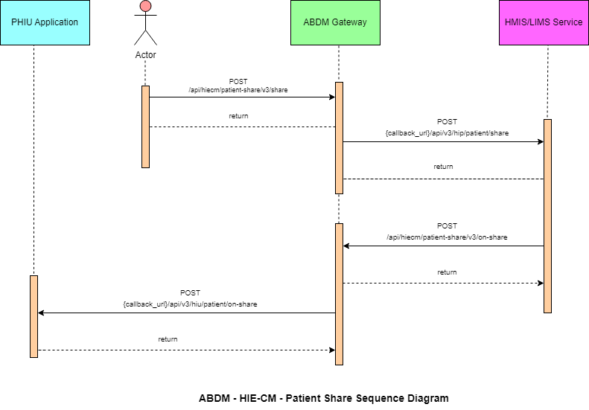

7.3 List of APIs

7.3.1 Profile share

This API will be invoked from the integrator application (any PHR application, just like ABHA) to share the user/patient profile with HMIS/LIMS.

URL: /api/hiecm/patient-share/v3/share
Method: POST
Request Headers:

Property  Name | Example Value | Require  d | Descriptio  n
REQUEST-ID | 18235d89-cb13-479d-ad71-  7a57d5f669a8 | Yes | Unique UUID for track the end to end request transaction

TIMESTAMP | 2022-10-06T10:10:00.587Z | Yes | Actual time when request was initiated, ISO Date time format represents date and time
Authorizatio n | eyJhbGciOiJSUzUxMiJ9. eyJzdWIiOiJ2YXNhbnRoYWt1bWFyLmtlc  2F2  YW5Ac2J4IiwiY2xpZW50SWQiOiJz  YngiLCJzeXN0ZW0iOiJBQkhBLUEiLCJy  ZXF1ZXN0ZXJJZCI6IlBIUi1XRUIiL  CJwaHJNb2JpbGUiOm51bGwsImV4c  CI6MTY2NzI5ODExNSwia  WF0IjoxNjY3MjkwOTE1LCJwaHJBZ  GRyZXNzIjoidmFzYW50aGFrdW1hci5rZX  NhdmFuQHNieCIsInR4bklkIjoi  YjEwMGM4ZDMtNTE1ZC00YWFiLTg1O  WQtYzNlMTUwOTE3ZGY1In0 | Yes | JWT Access token which  was issued  by ABDM session API after successful validation of client id and secret
X-HIU-ID | IN2810014366 | Yes | Identifier of the health information user to which the request was intended
X-CM-ID | sbx | Yes | Suffix of the consent manager to which the request was intended
X-  AUTHTOKEN | eyJhbGciOiJSUzUxMiJ9.eyJzdWIiOiJna XJpamFAc2J4IiwiY2xpZW50SWQiOiJQS FItV0VCIiwicmVxdWVzdGVySWQiOiJrX 2hpcCIsInN5c3RlbSI6IkFCRE0iLCJtb2Jp bGUiOiI4MjgxMTQ3MDgwIiwiZXhwIjoxNj c3NjY5NDU1LCJpYXQiOjE2Nzc2NjIyNTUs InRyYW5zYWN0aW9uSWQiOiJkMmY5O  TNkNi1kODg4LTQyMTMtOTc3My0wYmJj MzMwMjVhNGYiLCJhYmhhQWRkcmVzc  yI6ImdpcmlqYUBzYngifQ.Ad_jGrduH6 _krBBnlRO912mQabxMOiB0GN6FjdZjoi  CQY4AkUD3McGq2NR-XGAjHVpkRtKx69m4_44h-  FqTCbZlo09hq0SEM1KBMkPDl163JcFNM JGnXBa5E-mu6DpBSPA- VirSvBVj6CEpZLbTa2nBBSJJi_leszwHNr  kdope6rSc2G3SJfCW_DzFmzd_fxdvbFCN1yyhN3Rw5r8A1GnSrVSBhRjm4qy5O  _ gutl1XW9CaBaZSah7GOxGRr4gpSIJJvIL  WovwG58DyNzEhrHtAfIje_pegqRsNMO  FI-  xPYJd2x6CcDKSoAXvXO0jbuoOvlPl5kh plOKU-WcFeWA | Yes | JWT Access token which was issued by IDP service after successfully user authenticatio  n

Body Parameters:

Property  Name | Example Value | Require d | Description
intent | "PROFILE_SHARE" | Yes | This is a key value pair which contains the purpose with following possible values.  Profile_share  Payment  Health_record_sharing
metaData | {  "hipId": "Test_HIP", "context":  "ABC123", "hprId":  "abdulkalam@abdm", "latitude": "-38.679",  "longitude": "58.498" } | Yes | This is a key value pair which contains the location longitude and latitude
profile | {  "patient": {  "abhaNumber":  18443810806111,  "abhaAddress":  "1844381@abdm", | Yes | This is key value pair which contains patient details
"name": "User 1",
"gender": "M",
"dayOfBirth": "20",
"monthOfBirth": "1",
"yearOfBirth": "1999",
"address": {
"line": "C/O
Sandipan Kshirsagar
Ambejogai Road Renuka
Nagar Latur",
"district": null,
"state": null,
"pincode": null
}

"phoneNumber":
"9876543210"
}
}
Request Body

Request Body:

{
"intent": "PROFILE_SHARE",
"metaData": {
"hipId": "MAYUR_HIP",
"context": "ABC123",
"hprId": "abdulkalam@abdm",
"latitude": "-38.679",
"longitude": "58.498"
},
"profile": {
"patient": {
"abhaNumber": 91178386101251,
"abhaAddress": "9117838@sbx",
"name": "User 1",
"gender": "M",
"dayOfBirth": "10",
"monthOfBirth": "10",
"yearOfBirth": "1994",
"address": {
"line": "C/O Sandipan Kshirsagar Ambejogai Road Renuka Nagar",
"district": null,
"state": null,
"pincode": null
},
"phoneNumber": "9876543210"
}
}
}

Response
Response:
Code: 202 ACCEPTED

7.3.2 Profile share – Callback

This is a callback API for patient share API.

URL: {callback_url}/api/v3/hip/patient/share
Method: Post
Request Headers:

Property  Name | Example Value | Required | Description
REQUEST-ID | 18235d89-cb13-  479d-ad717a57d5f669a8 | Yes | Unique UUID for track the end to end request transaction
TIMESTAMP | 2022-10-  06T10:10:00.587Z | Yes | Actual time when request was initiated, ISO 8601 represents date and time by starting with the year, followed by the month, the day, the hour, the minutes, seconds and milliseconds
X-HIP-ID | IN2810014366 | Yes | Identifier of the health information provider to which the request was intended

Body parameters

Property Name | Example Value | Required | Description
intent | PROFILE_SHARE | Yes | This is a key value pair which contains the purpose with following possible values. Profile_share  Payment  Health_record_sharing
metaData | "metaData": {  "hipId": "MAYUR_HIP",  "context": "ABC123", | Yes | This is a key value pair which contains the location longitude and latitude
"hprId":
"abdulkalam@abdm",
"latitude": "-38.679",
"longitude": "58.498"
}
profile | "profile": {  "patient": {  "abhaNumber":  91178386176531,  "abhaAddress":  "91178386@sbx",  "name": "User 1",  "gender": "M",  "dayOfBirth": "10",  "monthOfBirth": "10",  "yearOfBirth": "1994",  "address": {  "line": "C/O Sandipan  Kshirsagar Ambejogai Road",  "district": null,  "state": null,  "pincode": null  },  "phoneNumber":  "9876543210"  } | Yes | This is key value pair which contains all the patient details

Request Body

Request Body:
{
"intent": "PROFILE_SHARE",
"metaData": {
"hipId": "MAYUR_HIP",
"context": "ABC123",
"hprId": "abdulkalam@abdm",
"latitude": "-38.679",
"longitude": "58.498"
},
"profile": {
"patient": {
"abhaNumber": 9117838615XXXX,
"abhaAddress": "91178XXXX@sbx",
"name": "User 1",
"gender": "M",
"dayOfBirth": "XX",
"monthOfBirth": "XX",
"yearOfBirth": "XXXX", "address": {
"line": "C/O Sandipan Kshirsagar Ambejogai Road Renuka Nagar",
"district": null,
"state": null,
"pincode": null
},
"phoneNumber": "987654XXXX"
} } }

Response

Response:
Response: In call back url below details should be displayed as per the Xauth token

{"intent":"PROFILE_SHARE","metaData":{"hipId":"MAYUR_HIP","context":"6","hprId":"abdulkal am@hpr.abdm","latitude":"-
38.670","longitude":"58.498"},"profile":{"patient":{"abhaNumber":"91178386156891","abhaAddr ess":"911783XX@sbx","name":"User 1",
"gender":"M","dayOfBirth":"XX","monthOfBirth":"XX","yearOfBirth":"XXXX","address":{"line":null
,"district":null,"state":null,"pincode":null},"phoneNumber":"987654XXXX"}}}
Code: 200 OK

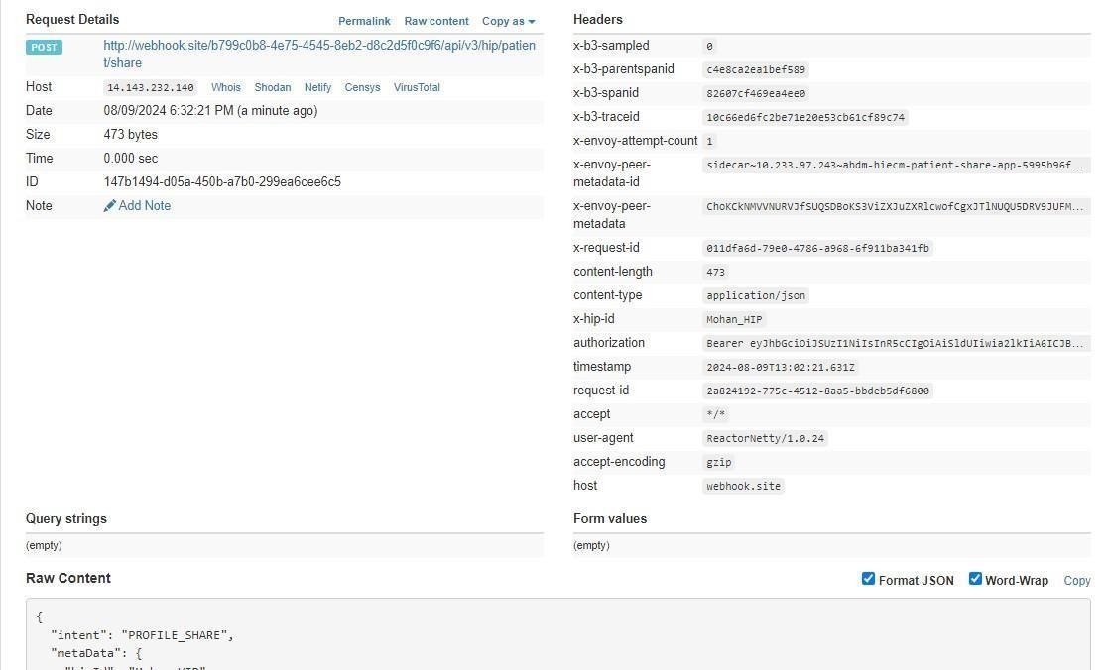

7.3.3 Profile on-share
This API will be invoked by HIP to acknowledge the request by the user/patient to share the profile details.

URL: /api/hiecm/patient-share/v3/on-share
Method: Post
Request Headers:

Property  Name | Example Value | Required | Description
REQUEST-ID | 18235d89-cb13-479d-ad71-  7a57d5f669a8 | Yes | Unique UUID for track the end to end request transaction
TIMESTAMP | 2022-10-06T10:10:00.587Z | Yes | Actual time when request was initiated, ISO 8601 represents date and time by starting with the year, followed by the month, the day, the hour, the minutes, seconds and milliseconds
Authorization | eyJhbGciOiJSUzUxMiJ9.  eyJzdWIiOiJ2YXNhbnRoYWt1bWFyLmtlc  2F2  YW5Ac2J4IiwiY2xpZW50SWQiOiJz  YngiLCJzeXN0ZW0iOiJBQkhBLUEiLCJy  ZXF1ZXN0ZXJJZCI6IlBIUi1XRUIiL  CJwaHJNb2JpbGUiOm51bGwsImV4c  CI6MTY2NzI5ODExNSwia  WF0IjoxNjY3MjkwOTE1LCJwaHJBZ  GRyZXNzIjoidmFzYW50aGFrdW1hci5rZX  NhdmFuQHNieCIsInR4bklkIjoi  YjEwMGM4ZDMtNTE1ZC00YWFiLTg1O  WQtYzNlMTUwOTE3ZGY1In0 | Yes | JWT Access token which was issued by ABDM session API after successful validation of client id and secret
X-CM-ID | sbx | Yes | Suffix of the consent manager to which the request was intended

Body Parameters

Property  Name | Example Value | Required | Description
abhaAddress | ABHA address | Yes | Patient ABHA address against which the health records needs to be linked
status | “SUCCESS” | Yes | Transaction status from HIP to HIECM,  “success”  “failed”
context | 43 | Yes | HMIS/LMIS Counter ID
tokenNumber | 3 | Yes | Token number at HMIS/LMIS to be provided to the patient
expiry | 180 | Yes | Patient year of birth
requestId | f29f0e59-8388-  46989fe605db67aeac46 | Yes | This is a key value pair which contains the purpose

Request Body

Request Body:
{
"acknowledgement": {
"abhaAddress": "abc@abdm",
"status": "success",
"profile": {
"context": "43",
"tokenNumber": "3",
"expiry": "180"
}
},
"response": {
"requestId": "f29f0e59-8388-4698-9fe6-05db67aeac46"
} }

Response

Response:
Code : 200 OK

Request Body : ERROR
-> Use this in case of error response (Ex: This is the one example for error payload and the code will be same. But, message will be change each error).

Request Body:
{
"error": {
"code": "ABDM-9999: ",
"message": "string
},
"response": {
"requestId": "6f0b4665-a915-4c92-aa36-65afb4a2cd71"
} }

7.3.4 Profile on share – Callback

This is a callback API for patient on-share API.

URL: {callback_url}/api/v3/hiu/patient/on-share
Method: Post
Request Headers:

Property  Name | Example Value | Required | Description
REQUEST-ID | 18235d89-cb13-  479d-ad717a57d5f669a8 | Yes | Unique UUID for track the end to end request transaction
TIMESTAMP | 2022-10-  06T10:10:00.587Z | Yes | Actual time when request was initiated, ISO 8601 represents date and time by starting with the year, followed by the month, the day, the hour, the minutes, seconds and milliseconds
X-HIU-ID | ABDM_sbx | Yes | Suffix of the HIU to which the request was intended
Body Parameters:

Property Name | Example Value | Required | Description
abhaAddress | ABHA address | Yes | Patient ABHA address against which the health records needs to be linked
Status | “success” | Yes | Trasaction status from HIP to HIE-CM,  “success”  “failed”
Context | 43 | Yes | HMIS/LMIS Counter ID
tokenNumber | 3 | Yes | Token number at HMIS/LMIS to be provided to the patient
Expiry | 180 | Yes | Patient year of birth
requestId | f29f0e59-8388-  46989fe605db67aeac46 | Yes | This is a key value pair which contains the purpose

Request Body

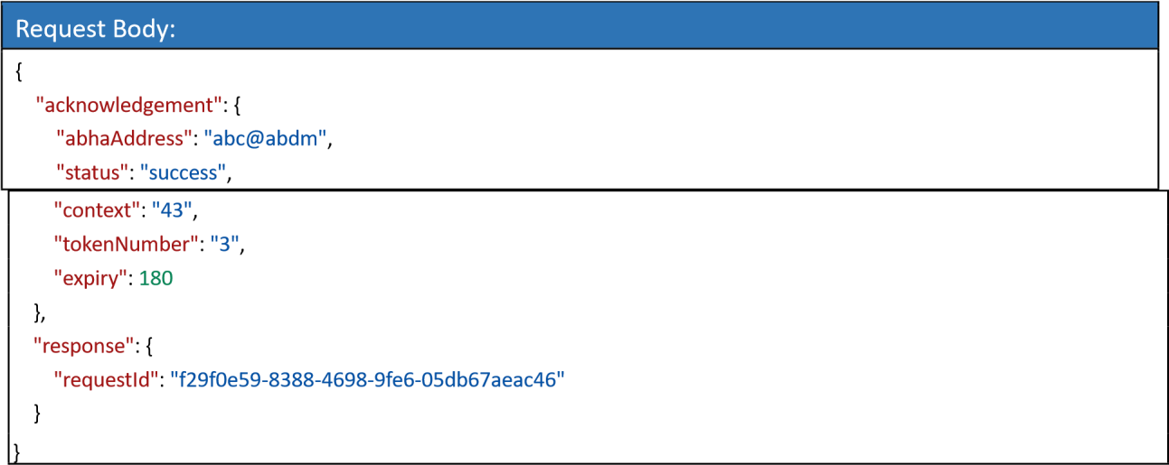

Response

Response:
Code: 200 OK
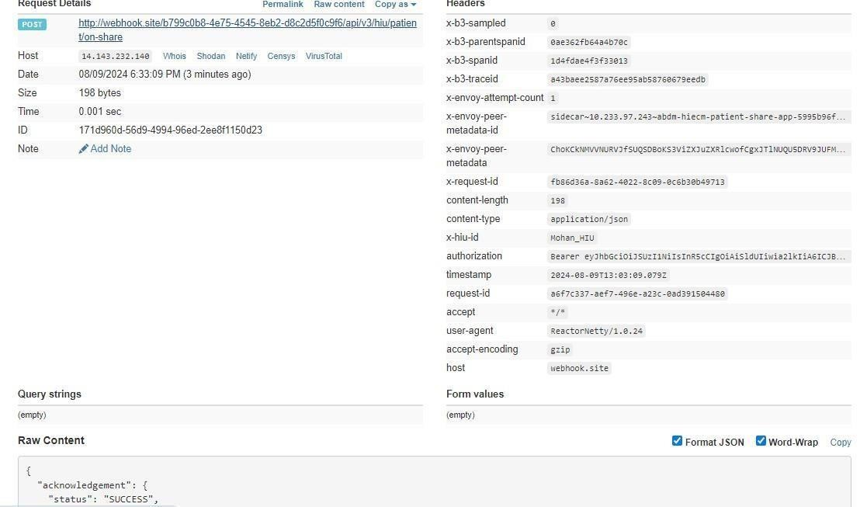

8.API Listing

No. | Flow | Serial | v3 API | Description
1 | HIP initiated linking | 1.1 | /api/hiecm/v3/token/gene rate-token | This generic API endpoint will be used to generate a linking token to link care context.
 |  | 1.2 | {callback_url}/api/v3/hip/token/ongeneratetoken | This is a Call-back API for hiecm/api/v3 /token/generatetoken
 |  | 1.3 | /api/hiecm/hip/v3/link/car econtext | This API needs to be called by the HIP to link the care context against the patient ABHA address, once the HIP has the valid linking token generated against the same patient ABHA address.
 |  | 1.4 | {callback_url}/api/v3/link/ on_carecontext | This is a Call-back API for hiecm/api/v3 /link/carecontext
 |  |  |  | This API will be invoked to get all the linked health records of the patient.
 |  | 1.5 | /api/hiecm/hip/v3/link/pat ient/links
 |  | 1.6 | /api/hiecm/hip/v3/link/co ntext/notify | This API will be invoked by HIP after updating a health record to notify all the subscribed HIUs.
 |  | 1.7 | {callbackURL}/api/v3/links/ context/onnotify | This is a callback api for  /hiecm/api/v3/link/context/notify API.
 |  | 1.8 | /api/hiecm/hip/v3/link/pat ient/links/sms/notify2 | This API will be invoked by HIP to trigger a SMS notification to the patient mobile number.
 |  | 1.9 | {callbackURL}/api/v3/patie nts/sms/onnotify | This is a callback API for  /hiecm/api/v3/link/patient/links/ sms/notify2 API call.
 |  | 1.10 | /api/hiecm/hip/v3/link/pat ient/links/hip/ondeactivate | This API will be invoked by HIP as a response on deactivating an abha address.
 |  | 1.11 | /api/hiecm/hip/v3/link/pat ient/links/hiu/ondeactivate | This API will be invoked by HIU as a response on deactivating an abha address.
2 | User initiated linking | 2.1 | /api/hiecm/userinitiated- linking/v3/patient/carecontext/discover | This API will be invoked by the patient/user from the PHR application to discover his/her health records.
 |  | 2.2 | {callback_url}/api/v3/hi p/patient/carecontext/discover | This API will be invoked by the HIE-CM to discover patient health records from  HIP.

 |  | 2.3 | /api/hiecm/userinitiatedlinking/v3/patient/carecontext/ondiscover | This API will be invoked by the HMIS/LIMS application  sharing  response for of the  discover API. the
 |  | 2.4 | {callback_url}/api/v3/hi u/patient/carecontext/on-discover | This API will be invoked by the HIECM  for sharing the response of the discover API.
 |  | 2.5 | /api/hiecm/userinitiated- linking/v3/link/carecontext/init | This is an API that will be invoked by the patient/user to link his/her health records.
 |  | 2.6 | {callback_url}/api/v3/hi p/link/care-context/init | This API will be invoked by the HIECM to link patient/user health records to HIP.
 |  | 2.7 | /api/hiecm/userinitiatedlinking/v3/link/carecontext/on-init | This is an API that will be invoked by the HIP to share the response of the init API.
 |  | 2.8 | {callback_url}/api/v3/hi u/patient/carecontext/on-init | This is an API that will be invoked by the  HIECM to share the response of the init  API with the Patient.
 |  | 2.9 | /api/hiecm/userinitiatedlinking/v3/link/carecontext/confirm | This API will be invoked by the patient/user to confirm his/her health records.
 |  | 2.10 | {callback_url}/api/v3/hi p/link/carecontext/confirm | This API will be invoked  by the HIECM to confirm patient/user health records to HIP.
 |  | 2.11 | /api/hiecm/userinitiatedlinking/v3/link/carecontext/onconfirm | This is an API that will be invoked by the HIP to share the response of the confirmed API.

 |  | 2.12 | {callback_url}/api/v3/hi u/patient/carecontext/on-confirm | This API will be invoked by the HIECM to share the response of confirm API to the patient.
3 | Patient Share | 3.1 | /api/hiecm/patientshare/v3/share | This API will be invoked from the integrator application (any PHR application, just like  ABHA) to share the user/patient profile with HMIS/LIMS.
 |  | 3.2 | {callback_url}/api/v3/hi p/patient/share | Callback API for patient share
 |  | 3.3 | /api/hiecm/patientshare/v3/on-share | This API will be invoked by HIP to acknowledge the request by the user/patient to share the profile details.
 |  | 3.4 | {callback_url}/api/v3/hi u/patient/on-share | Callback for Patient on-share
4 | Session | 4.1 | /api/hiecm/gateway/v3 /sessions | API to generate Auth token
5 | Gateway | 5.1 | /api/hiecm/gateway/v3 /bridge/url | API to update the bridge URL
 |  | 5.2 | /api/hiecm/gateway/v3 /certs | API to get keys from keycloak
 |  | 5.3 | /api/hiecm/gateway/v3 /.well-known/openidconfiguration | API to get OpenID configuration
 |  | 5.4 | /api/hiecm/gateway/v3  /bridge- service/serviceId/{servic eId} | API to fetch bridge details by service id
 |  | 5.5 | /api/hiecm/gateway/v3  /bridge-services | API to fetch all the service details from a bridge
6 | Data Flow | 6.1 | /api/hiecm/consent/v3/ request/hip/on-notify | API will be called by HIP to acknowledge the consent approval
 |  | 6.2 | /api/hiecm/dataflow/v3/healthinformation/hip/onrequest | API will be called by HIP to acknowledge  data flow request
 |  | 6.3 | /api- hiu/data/notification | Data transfer API to push data
 |  | 6.4 | /api/hiecm/dataflow/v3/healthinformation/notify | API called by HIP/HIU to notify the status of data transfer

9.Error Codes Listing
Code | Error
ABDM-1000 | Unable to connect the database
ABDM-1001 | No data found
ABDM-1002 | Integrity violation
ABDM-1003 | Email Gateway is unavailable
ABDM-1004 | SMS Gateway is unavailable
ABDM-1005 | Invalid receiver

ABDM-1006 | Bad Request, invalid request Body
ABDM-1007 | Connection failed due to timeout
ABDM-1008 | SMS service currently disabled
ABDM-1009 | Email service currently disabled
ABDM-1010 | Validation failed
ABDM-1011 | Gateway database unavailable
ABDM-1012 | No records found against the ABHA Address
ABDM-1013 | Invalid ABHA Number
ABDM-1014 | Invalid Mobile Email
ABDM-1015 | Invalid Response
ABDM-1016 | Invalid TimeStamp
ABDM-1017 | Invalid TransactionId
ABDM-1018 | Share Profile database unavailable
ABDM-1019 | Dependent Service Unavailable
ABDM-1020 | Unknown database
ABDM-1021 | Lack of required priviledges
ABDM-1022 | Too many requests
ABDM-1023 | Invalid User
ABDM-1024 | Dependent service unavailable
ABDM-1025 | Invalid ServiceId
ABDM-1026 | Invalid Link Token
ABDM-1027 | You are blocked. Please try again after 24 hours.
ABDM-1028 | HIP is unavailable
ABDM-1029 | Redis server is unavailable
ABDM-1030 | Invalid request ID
ABDM-1031 | Invalid request
ABDM-1032 | Invalid header
ABDM-1033 | HIU is unavailable

ABDM-1034 | Notification service unavailable
ABDM-1035 | Invalid HIP ID
ABDM-1035 | OTP does not matched
ABDM-1036 | Data does not matched
ABDM-1037 | Counter and Care context count mismatch
ABDM-1038 | ABHA address and Link token mismatch
ABDM-1039 | Invalid Consent request id
ABDM-1040 | Invalid HIU ID
ABDM-1041 | Invalid Acknowledgement
ABDM-1042 | Provider Mandatory
ABDM-1043 | ABHA Address does not match with KYC details.

ABDM-1044 | Broadcast Failed
ABDM-1045 | Database Access is restricted
ABDM-1046 | Invalid Purpose
ABDM-1047 | Purpose does not exist
ABDM-1048 | Timeout
ABDM-1049 | Invalid Profile Share Intent Keys
ABDM-1050 | Invalid Profile Share Metadata Keys
ABDM-1051 | Invalid ABHA Number or ABHA Address
ABDM-1052 | Invalid TransactionId or response's requestId
ABDM-1053 | Data already exists
ABDM-1054 | Invalid Subscription Request Id
ABDM-1401 | HIP is not available
ABDM-1402 | Acknowledgement is not received from HIP
ABDM-9999 | Unknown exception
ABDM-1061 | Consent artefact expired
ABDM-1062 | Consent Not granted
ABDM-1063 | Date Range given is invalid
ABDM-1064 | request with this request id already exists
ABDM-1017 | Invalid TransactionId
ABDM-1109 | ABHA DB service unavailable
ABDM-1108 | Notification DB service unavailable
ABDM-1205 | Document DB Gateway is unavailable
ABDM-1034 | Notification service unavailable
ABDM-1029 | Redis server is unavailable
ABDM-1202 | Document Gateway is unavailable
ABDM-1200 | LGD Gateway is unavailable
ABDM-1201 | IDP Gateway is unavailable
ABDM-9999 | Unknown exception
ABDM-1101 | This ABHA Address already exists. Please create with unique ABHA Address
ABDM-1006 | Invalid combinations of scopes
ABDM-1100 | You have requested multiple OTPs Or Exceeded maximum number of attempts for OTP match in this transaction. Please try again in 30 minutes.
ABDM-1006 | Bad Request, invalid request Body

